**CARESTREAM HEALTH**

|  |  |
| --- | --- |
| **Part Number :** | **Autour : Ralf Wang** |
| **Project : KIOSK PUMA System** | **Product : KIOSK** |
| **Document Title: Kiosk PUMA Reliability Testing Report** | |

**TABLE OF CONTENTS**

[1 Test Environment 2](#_Toc488064487)

[2 Test Requirement 2](#_Toc488064488)

[2.1 Test Scenario 3](#_Toc488064489)

[2.2 Test Tool 3](#_Toc488064490)

[3 Testing work （Phase 1） 4](#_Toc488064491)

[3.1 Strategy and Scenario Setting 4](#_Toc488064492)

[3.2 Background Data 4](#_Toc488064493)

[3.3 Other Setting: 5](#_Toc488064494)

[3.3.1 Database setting 5](#_Toc488064495)

[3.3.2 IIS setting 5](#_Toc488064496)

[3.4 Test Object version 5](#_Toc488064497)

[3.5 Test result 5](#_Toc488064498)

[3.5.1 Test Statistic Report 5](#_Toc488064499)

[3.5.2 Transaction summary result: 6](#_Toc488064500)

[3.5.3 Transaction response time result 7](#_Toc488064501)

[3.6 Bottleneck analysis 7](#_Toc488064502)

[3.6.1 Hardware usage analysis 7](#_Toc488064503)

[3.6.2 SQL Server resource usage analysis 9](#_Toc488064504)

[3.7 Test Error 11](#_Toc488064505)

[3.8 Test Conclusion 11](#_Toc488064506)

# Test Environment

Test environment：We use the follow machine to do our performance testing work.

|  |  |  |  |  |  |  |  |  |  |  |  |
| --- | --- | --- | --- | --- | --- | --- | --- | --- | --- | --- | --- |
| **Server Name** | **Type** | **CPU** | | **Hard Disk** | | **RAM** | | **OS** | | **Required Software** | |
| PS Server | Hyper-v virtual machine | Intel Xeon E5-2620 v3 2.40GHz \*12 | 2T SCSI Disk  Seagate MD3002 | | 32G | | Windows 2012 R2 | | SQL 2012  IIS 8 | |
| QTP script machine | Hyper-v virtual machine | Intel Xeon E5-2403 v2 1.80GHz \*4 | 80G Virtual Disk | | 2.5G | | Windows 2012 R2 | | QTP 11 demo | |
| Performance control | Dell optiplex 9020 | Intel core(TM) i7-4790 3.6GHZ\*6 | 1T SATA Disk | | 8G | | Win7 64bit | | Load runner | |

Figure 1.1 Hardware List

# Test Requirement

The PUMA system will support reporting and notice push service for different department of entire hospital. We will integrate with the 3rd party system and patients can print their reports in ONE terminal. The message push service will also be included in the product. Patient can query different information and get the report status notice service from the product.

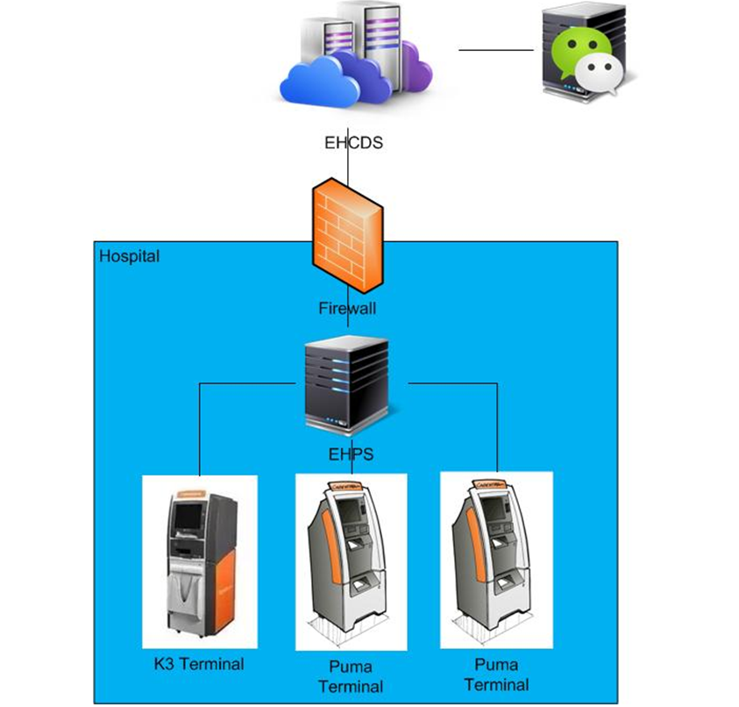

Figure2.1 System structure

We will do the reliability testing work to make sure the system can fit the requirements and services work well. The detail plan and strategy please reference the content in document as follow:



## Test Scenario

The testing work will simulate the real work flow include Print film from workstation, OCR operations, terminal print film, terminal print report and etc.

## Test Tool

QTP: Simulate doctor print film from workstation.

Load Runner: Simulate the doctor and patient operation by http or web service.

# Testing work （Phase 1）

## Strategy and Scenario Setting

1. Use automation tool simulate the doctor print film work. Simulate 8 GX Platform by using QTP and PDSender tool. Each client prints one film which size is 10MB every 30 seconds.
2. Use LR tool simulate 8 K2/K3 terminals to print film. Each client prints one film which size is 10MB random 5 to 30 seconds.
3. Use LR tool simulate 45 PUMA terminals to print paper reports. Each client prints report random 5 to 30 seconds.
4. Use LR tool simulate the PUMA report archive operations. Each client archive report in random 5 to 30 seconds and size is random with 100kb and 4Mb.
5. The OCR setting is cover the rule for GX platforms in step1 and other setting are set as default.
6. Execute QTP script to simulate a real terminal to print 100 patient`s report as cycle.
7. Monitor the hardware resource usage on PS.
8. Monitor the resource usage for database on PS.
9. Start/Stop 2 virtual users every 5 seconds and run the scenario for 7\*24 hours.

## Background Data

We use SQL command statement to add large data in the database, the detail information as follow:

|  |  |
| --- | --- |
| **Table Name** | **Data Volume (records)** |
| printer.dbo.DeliveryJob | 896813 |
| printer.dbo.ImageBox | 997879 |
| printer.dbo.Page | 997813 |
| printer.dbo.Session | 1001132 |
| wggc.dbo.Patient | 1029777 |
| wggc.dbo.Study | 1029789 |
| wggc.dbo.AFP\_PrintTerminalInfo | 62 |
| wggc.dbo.Series | 1029735 |
| wggc.dbo.Image | 1029738 |
| wggc.dbo.AFP\_FilmInfo | 1043592 |
| wggc.dbo.AFP\_ReportInfo | 936761 |
| wggc.dbo.AFP\_ExamInfo | 1997005 |
| wggc.dbo.AFP\_PrintTask | 3696324 |
| wggc.dbo.T\_Integration\_ExamInfo | 119292 |
| AFP\_PrintMode | 87883 |
| wggc.dbo.vi\_KIOSK\_ExamInfo\_Order | 119331 |

Figure 3.2.1 Background Data

## Other Setting:

### Database setting

Memory: Set the min and max memory size to 8GB.

Index fill factor: 80.

File: Increase the data and log files size and the rule is increase 500Mb as fixed size.

### IIS setting

Connection: Keep with setting which change by the PS install package.

## Test Object version

KIOSK Platform 3.0.0.1 B0801

Developer team updated some SQL statement, add some no lock operates in the SQL. It seems enhance the performance of the PS system.

## Test result

### Test Statistic Report

|  |
| --- |
| Statistics Summary |

|  |  |  |
| --- | --- | --- |
| [**Maximum Running Vusers:**](file:///C:\Users\Administrator\AppData\Local\Temp\VuserStateGraph) |  | 98 |
| [**Total Hits:**](file:///C:\Users\Administrator\AppData\Local\Temp\HitsperSecond) | [Show SLA Results](slarules:total_hits) | 656,499 |
| [**Average Hits per Second:**](file:///C:\Users\Administrator\AppData\Local\Temp\HitsperSecond) | [Show SLA Results](slarules:average_hits) | 11.061 | [**View HTTP Responses Summary**](file:///C:\Users\Administrator\AppData\Local\Temp\1091964346.html#1) |
| [**Total Errors:**](file:///C:\Users\Administrator\AppData\Local\Temp\TotalErrorsPerSecond) | [Show SLA Results](slarules:errors_per_second) | 358 |  |

|  |
| --- |
| Transaction Summary |

|  |  |  |  |  |
| --- | --- | --- | --- | --- |
| [**Transactions:**](file:///C:\Users\Administrator\AppData\Local\Temp\TransactionSummary) | Total Passed: 744,934 | Total Failed: 88 | Total Stopped: 15 | [**Average Response Time**](file:///C:\Users\Administrator\AppData\Local\Temp\ResponseTime) |

|  |  |  |  |  |  |  |  |  |  |
| --- | --- | --- | --- | --- | --- | --- | --- | --- | --- |
| **Transaction Name** | **SLA Status** | **Minimum** | **Average** | **Maximum** | **Std. Deviation** | **90 Percent** | **Pass** | **Fail** | **Stop** |
| [Create New Patient](file:///C:\Users\Administrator\AppData\Local\Temp\ResponseTime0000(Create%20New%20Patient)0000) | [Show SLA Results](slarules:transaction_response_time_CreateNewPatient) | 0.286 | 0.829 | 5.031 | 0.416 | 1.177 | 89,924 | 0 | 0 |
| [Film Create\_PrintTask](file:///C:\Users\Administrator\AppData\Local\Temp\ResponseTime0000(Film%20Create_PrintTask)0000) | [Show SLA Results](slarules:transaction_response_time_FilmCreate_PrintTask) | 0.016 | 0.105 | 8.434 | 0.174 | 0.164 | 8,454 | 0 | 0 |
| [Film PrintTask](file:///C:\Users\Administrator\AppData\Local\Temp\ResponseTime0000(Film%20PrintTask)0000) | [Show SLA Results](slarules:transaction_response_time_FilmPrintTask) | 0.14 | 1.15 | 6.842 | 0.573 | 1.775 | 8,454 | 0 | 0 |
| [Film PrintTask\_Result\_Correct](file:///C:\Users\Administrator\AppData\Local\Temp\ResponseTime0000(Film%20PrintTask_Result_Correct)0000) | [Show SLA Results](slarules:transaction_response_time_FilmPrintTask_Result_Correct) | 0 | 0 | 0.016 | 0 | 0 | 8,452 | 0 | 0 |
| [Film PrintTask\_Result\_Fail](file:///C:\Users\Administrator\AppData\Local\Temp\ResponseTime0000(Film%20PrintTask_Result_Fail)0000) | [Show SLA Results](slarules:transaction_response_time_FilmPrintTask_Result_Fail) | 0 | 0 | 0 | 0 | 0 | 0 | 2 | 0 |
| [Film TerminalStatus](file:///C:\Users\Administrator\AppData\Local\Temp\ResponseTime0000(Film%20TerminalStatus)0000) | [Show SLA Results](slarules:transaction_response_time_FilmTerminalStatus) | 0.016 | 0.082 | 2.732 | 0.075 | 0.125 | 16,908 | 0 | 0 |
| [Film\_PrintStatus\_CheckService](file:///C:\Users\Administrator\AppData\Local\Temp\ResponseTime0000(Film_PrintStatus_CheckService)0000) | [Show SLA Results](slarules:transaction_response_time_Film_PrintStatus_CheckService) | 0.017 | 0.08 | 6.954 | 0.113 | 0.121 | 23,896 | 0 | 0 |
| [Notify File 100k](file:///C:\Users\Administrator\AppData\Local\Temp\ResponseTime0000(Notify%20File%20100k)0000) | [Show SLA Results](slarules:transaction_response_time_NotifyFile100k) | 0.987 | 11.234 | 26.454 | 2.833 | 15.008 | 88,107 | 86 | 0 |
| [Notify File 4M](file:///C:\Users\Administrator\AppData\Local\Temp\ResponseTime0000(Notify%20File%204M)0000) | [Show SLA Results](slarules:transaction_response_time_NotifyFile4M) | 2.342 | 11.451 | 29.657 | 3.761 | 16.63 | 1,731 | 0 | 0 |
| [Report QueryFilmReportInfo](file:///C:\Users\Administrator\AppData\Local\Temp\ResponseTime0000(Report%20QueryFilmReportInfo)0000) | [Show SLA Results](slarules:transaction_response_time_ReportQueryFilmReportInfo) | 0.007 | 0.039 | 0.12 | 0.011 | 0.053 | 199,591 | 0 | 5 |
| [Report TerminalStatus](file:///C:\Users\Administrator\AppData\Local\Temp\ResponseTime0000(Report%20TerminalStatus)0000) | [Show SLA Results](slarules:transaction_response_time_ReportTerminalStatus) | 0.027 | 0.083 | 1.482 | 0.048 | 0.117 | 199,608 | 0 | 10 |
| [Report Update report printer info](file:///C:\Users\Administrator\AppData\Local\Temp\ResponseTime0000(Report%20Update%20report%20printer%20info)0000) | [Show SLA Results](slarules:transaction_response_time_ReportUpdatereportprinterinfo) | 0.067 | 0.144 | 3.521 | 0.099 | 0.197 | 99,809 | 0 | 0 |

Figure 3.5.1.1 Summary Report

Follow the summary result information: we can get the information that:

We stop the testing work because there are some errors happened during the testing work.

All testing work duration time is 16 hours and 29 minutes. There are 74,934 transactions passed, 88 transactions failed and 15 virtual users stop execute. The follow transactions` response times are not meets the requirements and value is large:

|  |  |  |  |  |  |  |  |  |  |
| --- | --- | --- | --- | --- | --- | --- | --- | --- | --- |
| **Transaction Name** | **SLA Status** | **Minimum** | **Average** | **Maximum** | **Std. Deviation** | **90 Percent** | **Pass** | **Fail** | **Stop** |
| [Film PrintTask\_Result\_Fail](file:///C:\Users\Administrator\AppData\Local\Temp\ResponseTime0000(Film%20PrintTask_Result_Fail)0000) | [Show SLA Results](slarules:transaction_response_time_FilmPrintTask_Result_Fail) | 0 | 0 | 0 | 0 | 0 | 0 | 2 | 0 |
| [Notify File 100k](file:///C:\Users\Administrator\AppData\Local\Temp\ResponseTime0000(Notify%20File%20100k)0000) | [Show SLA Results](slarules:transaction_response_time_NotifyFile100k) | 0.987 | 11.234 | 26.454 | 2.833 | 15.008 | 88,107 | 86 | 0 |
| [Notify File 4M](file:///C:\Users\Administrator\AppData\Local\Temp\ResponseTime0000(Notify%20File%204M)0000) | [Show SLA Results](slarules:transaction_response_time_NotifyFile4M) | 2.342 | 11.451 | 29.657 | 3.761 | 16.63 | 1,731 | 0 | 0 |

Figure 3.5.1.1 value of response time

The team should focus on the tuning works to enhance the service reliability and find out the reason why some transactions are failed.

### Transaction summary result:

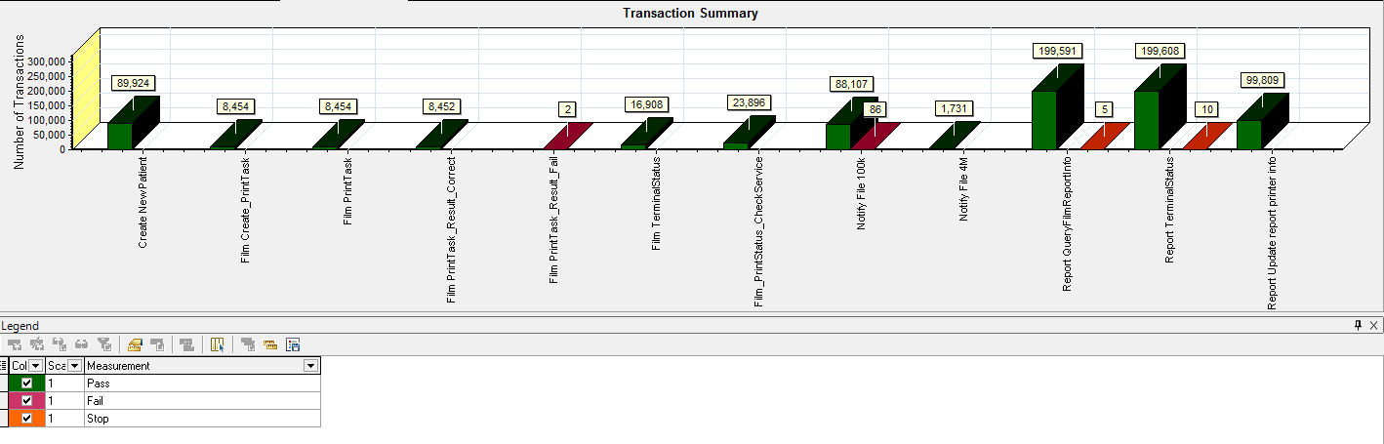

Figure 3.5.2.1 Transaction Summary

We can notice that there are some transactions failed during the testing work. We should find out the reason and fix it in the next version.

### Transaction response time result

We can get the transaction response time information from the figure as follow:

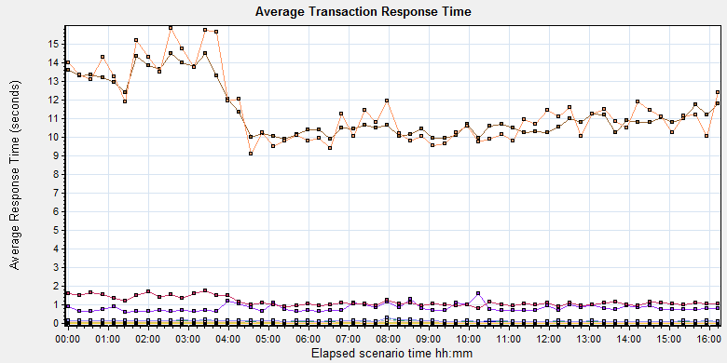

|  |  |  |  |  |  |  |  |
| --- | --- | --- | --- | --- | --- | --- | --- |
| **Color** | **Scale** | **Measurement** | **Graph's Minimum** | **Graph's Average** | **Graph's Maximum** | **Graph's Median** | **Graph's Std. Deviation** |
|  | 1 | Create New Patient | 0.624 | 0.827 | 1.614 | 0.746 | 0.195 |
|  | 1 | Film Create\_PrintTask | 0.072 | 0.105 | 0.309 | 0.095 | 0.033 |
|  | 1 | Film PrintTask | 0.814 | 1.154 | 1.765 | 1.068 | 0.235 |
|  | 1 | Film PrintTask\_Result\_Correct | 0 | 0 | 0 | 0 | 0 |
|  | 1 | Film TerminalStatus | 0.061 | 0.082 | 0.175 | 0.074 | 0.021 |
|  | 1 | Film\_PrintStatus\_CheckService | 0.058 | 0.08 | 0.2 | 0.069 | 0.025 |
|  | 1 | Notify File 100k | 9.863 | 11.304 | 14.486 | 10.767 | 1.404 |
|  | 1 | Notify File 4M | 9.09 | 11.45 | 15.824 | 11.1 | 1.779 |
|  | 1 | Report QueryFilmReportInfo | 0.032 | 0.039 | 0.046 | 0.038 | 0.003 |
|  | 1 | Report TerminalStatus | 0.064 | 0.082 | 0.149 | 0.073 | 0.018 |
|  | 1 | Report Update report printer info | 0.114 | 0.142 | 0.277 | 0.131 | 0.031 |

C:\Users\Administrator\AppData\Local\Temp\Report\dot_trans.gif

|  |
| --- |
| **Description:**Displays the average time taken to perform transactions during each second of the load test. This graph helps you determine whether the performance of the server is within acceptable minimum and maximum transaction performance time ranges defined for your system. |
|  |

|  |
| --- |
|  |
|  |

Figure 3.5.3.1 Transaction response time

This figure information shows all transactions` response time. We can analysis that there are four transaction time is very big which mentioned in chapter 3.5.1. There are: Notify File 4M, Notify File 100k. The service for these transactions should enhance.

## Bottleneck analysis

### Hardware usage analysis

During the testing work, we use the test tool to monitor the server hardware usage include the CPU, Memory, hard disk and etc.

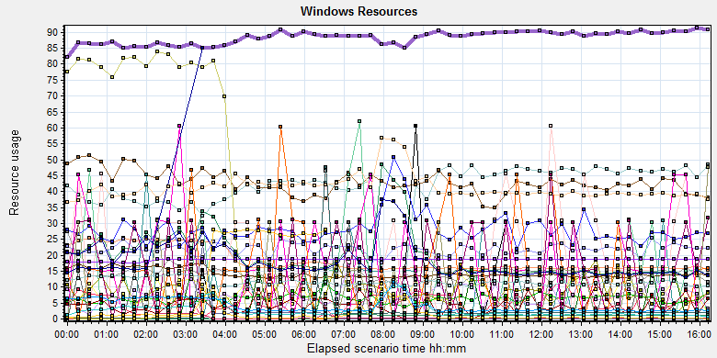

|  |  |  |  |  |  |  |
| --- | --- | --- | --- | --- | --- | --- |
| **Color** | **Scale** | **Measurement** | **Minimum** | **Average** | **Maximum** | **Std. Deviation** |
|  | 0.1 | % Disk Read Time (PhysicalDisk \_Total):10.184.129.208 | 0 | 14.08 | 10617.983 | 146.372 |
|  | 0.1 | % Disk Time (PhysicalDisk \_Total):10.184.129.208 | 22.407 | 197.435 | 12020.796 | 269.858 |
|  | 0.1 | % Disk Write Time (PhysicalDisk \_Total):10.184.129.208 | 22.013 | 183.355 | 11298.787 | 187.305 |
|  | 1 | % Idle Time (PhysicalDisk \_Total):10.184.129.208 | 0 | 40.951 | 81.077 | 18.329 |
|  | 1000 | % Interrupt Time (Processor \_Total):10.184.129.208 | 0 | 0.043 | 0.859 | 0.047 |
|  | 10 | % Privileged Time (Processor \_Total):10.184.129.208 | 0.086 | 1.834 | 4.573 | 0.552 |
|  | 10 | % Processor Time (Process AcquisitionServer):10.184.129.208 | 0 | 2.106 | 26.564 | 4.22 |
|  | 10000 | % Processor Time (Process auditServer):10.184.129.208 | 0 | 0.002 | 1.036 | 0.031 |
|  | 100 | % Processor Time (Process AutoDeliveryServer):10.184.129.208 | 0 | 0.219 | 2.604 | 0.338 |
|  | 1000 | % Processor Time (Process AutoForwardFilmService):10.184.129.208 | 0 | 0.008 | 1.042 | 0.065 |
|  | 10000 | % Processor Time (Process JP2MngSrv):10.184.129.208 | 0 | 0.001 | 1.042 | 0.022 |
|  | 1000 | % Processor Time (Process Kiosk.Alarm.KService):10.184.129.208 | 0 | 0.005 | 1.562 | 0.056 |
|  | 100 | % Processor Time (Process LogServer):10.184.129.208 | 0 | 0.143 | 3.109 | 0.301 |
|  | 100 | % Processor Time (Process MessageQueue):10.184.129.208 | 0 | 0.064 | 6.748 | 0.201 |
|  | 10000 | % Processor Time (Process OamServer):10.184.129.208 | 0 | 0 | 2.073 | 0.018 |
|  | 1000 | % Processor Time (Process OcrService):10.184.129.208 | 0 | 0.009 | 1.042 | 0.068 |
|  | 10000 | % Processor Time (Process PDCSenderServer):10.184.129.208 | 0 | 0.001 | 0.521 | 0.019 |
|  | 100 | % Processor Time (Process PrinterMonitor):10.184.129.208 | 0 | 0.28 | 7.254 | 0.481 |
|  | 10 | % Processor Time (Process PrintScheduler):10.184.129.208 | 0 | 1.418 | 10.938 | 1.387 |
|  | 10000 | % Processor Time (Process PrintSCPServer):10.184.129.208 | 0 | 0.001 | 0.523 | 0.027 |
|  | 1000 | % Processor Time (Process PrintServer):10.184.129.208 | 0 | 0.007 | 1.042 | 0.062 |
|  | 10000 | % Processor Time (Process PSNotificationService):10.184.129.208 | 0 | 0.001 | 1.036 | 0.026 |
|  | 10000 | % Processor Time (Process RequestServer):10.184.129.208 | 0 | 0 | 0.521 | 0.01 |
|  | 1000 | % Processor Time (Process RuleServer):10.184.129.208 | 0 | 0.004 | 1.042 | 0.048 |
|  | 0.1 | % Processor Time (Process sqlservr):10.184.129.208 | 153.283 | 883.881 | 1088.542 | 95.938 |
|  | 10000 | % Processor Time (Process sqlwriter):10.184.129.208 | 0 | 0 | 0.529 | 0.012 |
|  | 10000 | % Processor Time (Process SSCPServer):10.184.129.208 | 0 | 0.001 | 1.036 | 0.027 |
|  | 10000 | % Processor Time (Process TaskManager):10.184.129.208 | 0 | 0.001 | 1.036 | 0.018 |
|  | 0.1 | % Processor Time (Process w3wp#1):10.184.129.208 | 0 | 19.901 | 158104.448 | 1126.035 |
|  | 0.1 | % Processor Time (Process w3wp#2):10.184.129.208 | 0 | 7.969 | 79347.93 | 565.173 |
|  | 1 | % Processor Time (Process w3wp#3):10.184.129.208 | 0 | 0.957 | 4617.092 | 32.891 |
|  | 0.1 | % Processor Time (Process w3wp#4):10.184.129.208 | 0 | 6.053 | 56027.47 | 400.544 |
|  | 10 | % Processor Time (Process w3wp#5):10.184.129.208 | 0 | 1.258 | 12.5 | 1.772 |
|  | 1 | % Processor Time (Process w3wp#6):10.184.129.208 | 0 | 15.731 | 153.886 | 5.99 |
|  | 10 | % Processor Time (Process w3wp):10.184.129.208 | 0 | 1.16 | 10.88 | 0.908 |
|  | 0.001 | Available MBytes (Memory):10.184.129.208 | 17569 | 18598.289 | 19281 | 338.119 |
|  | 10 | Avg. Disk Read Queue Length (PhysicalDisk \_Total):10.184.129.208 | 0 | 0.141 | 106.18 | 1.462 |
|  | 10 | Avg. Disk Write Queue Length (PhysicalDisk \_Total):10.184.129.208 | 0.22 | 1.834 | 112.988 | 1.873 |
|  | 1 | Disk Reads/sec (PhysicalDisk \_Total):10.184.129.208 | 0 | 2.626 | 266.201 | 6.302 |
|  | 1 | Disk Transfers/sec (PhysicalDisk \_Total):10.184.129.208 | 9.632 | 41.262 | 266.865 | 17.529 |
|  | 1E-06 | Disk Write Bytes/sec (PhysicalDisk \_Total):10.184.129.208 | 35388.101 | 4013387.318 | 25225417.692 | 3670228.666 |

C:\Users\Administrator\AppData\Local\Temp\Report\dot_trans.gif

|  |
| --- |
| **Description:**Displays a summary of the System Resources usage for each Windows based host. |
|  |

Follow this information we can get that:

The CPU usage do not exist bottleneck, the idle process time is 40-80% (*% Idle Time (PhysicalDisk \_Total)*), the CPU do not has stress. The most the process operation is focus on the database. (*% Processor Time (Process sqlservr)* the value of this performance index should divided the numbers of CPUs (12))

The memory available value is 18.6G and the system use 1.7 G. The memory do not has bottleneck under current testing stress.

### SQL Server resource usage analysis

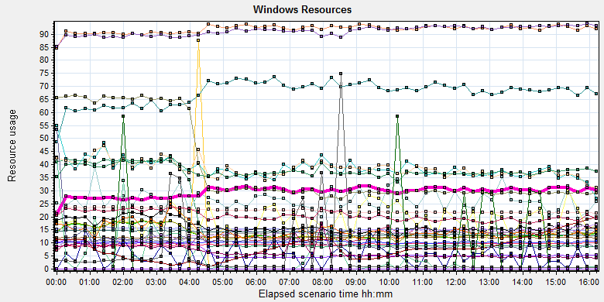

|  |  |  |  |  |  |  |  |  |  |  |  |  |  |  |  |  |  |  |  |  |  |  |  |  |  |  |  |  |  |  |  |  |  |  |  |  |  |  |  |  |  |  |  |  |  |  |  |  |  |  |  |  |  |  |  |  |  |  |  |  |  |  |  |  |  |  |  |  |  |  |  |  |  |  |  |  |  |  |  |  |  |  |  |  |  |  |  |  |  |  |  |  |  |  |  |  |  |  |  |  |  |  |  |  |  |  |  |  |  |  |  |  |  |  |  |  |  |  |  |  |  |  |  |  |  |  |  |  |  |  |  |  |  |  |  |  |  |  |  |  |  |  |  |  |  |  |  |  |  |  |  |  |  |  |  |  |  |  |  |  |  |  |  |  |  |  |  |  |  |  |  |  |  |  |  |  |  |  |  |  |  |  |  |  |  |  |  |  |  |  |  |  |  |  |  |  |  |  |  |  |  |  |  |  |  |  |  |  |  |  |  |  |  |  |  |  |  |  |  |  |  |  |  |  |  |  |  |  |  |  |  |  |  |  |  |  |  |  |  |  |  |  |  |  |  |  |  |  |  |  |  |  |  |  |  |  |  |  |  |  |  |  |  |  |  |  |  |  |  |  |  |  |  |  |  |  |  |  |  |  |
| --- | --- | --- | --- | --- | --- | --- | --- | --- | --- | --- | --- | --- | --- | --- | --- | --- | --- | --- | --- | --- | --- | --- | --- | --- | --- | --- | --- | --- | --- | --- | --- | --- | --- | --- | --- | --- | --- | --- | --- | --- | --- | --- | --- | --- | --- | --- | --- | --- | --- | --- | --- | --- | --- | --- | --- | --- | --- | --- | --- | --- | --- | --- | --- | --- | --- | --- | --- | --- | --- | --- | --- | --- | --- | --- | --- | --- | --- | --- | --- | --- | --- | --- | --- | --- | --- | --- | --- | --- | --- | --- | --- | --- | --- | --- | --- | --- | --- | --- | --- | --- | --- | --- | --- | --- | --- | --- | --- | --- | --- | --- | --- | --- | --- | --- | --- | --- | --- | --- | --- | --- | --- | --- | --- | --- | --- | --- | --- | --- | --- | --- | --- | --- | --- | --- | --- | --- | --- | --- | --- | --- | --- | --- | --- | --- | --- | --- | --- | --- | --- | --- | --- | --- | --- | --- | --- | --- | --- | --- | --- | --- | --- | --- | --- | --- | --- | --- | --- | --- | --- | --- | --- | --- | --- | --- | --- | --- | --- | --- | --- | --- | --- | --- | --- | --- | --- | --- | --- | --- | --- | --- | --- | --- | --- | --- | --- | --- | --- | --- | --- | --- | --- | --- | --- | --- | --- | --- | --- | --- | --- | --- | --- | --- | --- | --- | --- | --- | --- | --- | --- | --- | --- | --- | --- | --- | --- | --- | --- | --- | --- | --- | --- | --- | --- | --- | --- | --- | --- | --- | --- | --- | --- | --- | --- | --- | --- | --- | --- | --- | --- | --- | --- | --- | --- | --- | --- | --- | --- | --- | --- | --- | --- | --- | --- | --- | --- | --- | --- | --- | --- | --- | --- | --- | --- | --- | --- | --- | --- | --- | --- | --- |
| |  |  |  |  |  |  |  | | --- | --- | --- | --- | --- | --- | --- | | **Color** | **Scale** | **Measurement** | **Minimum** | **Average** | **Maximum** | **Std. Deviation** | |  | 0.0001 | Cursor memory usage (MSSQL$GCPACSWS|Cursor Manager by Type \_Total):10.184.129.208 | 40952 | 63360.729 | 119896 | 22300.092 | |  | 10 | Cursor Requests/sec (MSSQL$GCPACSWS|Cursor Manager by Type \_Total):10.184.129.208 | 0 | 1.725 | 11.624 | 1.699 | |  | 10 | Distributed Query (MSSQL$GCPACSWS|Exec Statistics Average execution time (ms)):10.184.129.208 | 0 | 1.218 | 138 | 2.417 | |  | 10000 | Distributed Query (MSSQL$GCPACSWS|Exec Statistics Cumulative execution time (ms) per second):10.184.129.208 | 0 | 0 | 3 | 0.021 | |  | 1000 | Distributed Query (MSSQL$GCPACSWS|Exec Statistics Execs in progress):10.184.129.208 | 0 | 0.005 | 1 | 0.071 | |  | 1E-17 | Distributed Query (MSSQL$GCPACSWS|Exec Statistics Execs started per second):10.184.129.208 | 0 | 2.6452747030728E+18 | 1.84467440737095E+19 | 6.46523218434761E+18 | |  | 1 | Errors/sec (MSSQL$GCPACSWS|SQL Errors \_Total):10.184.129.208 | 0.332 | 12.114 | 35.465 | 2.829 | |  | 10 | Errors/sec (MSSQL$GCPACSWS|SQL Errors User Errors):10.184.129.208 | 0 | 9.188 | 17.904 | 2.288 | |  | 1 | Extended Procedures (MSSQL$GCPACSWS|Exec Statistics Average execution time (ms)):10.184.129.208 | 0 | 0 | 0 | 0 | |  | 0.1 | Full Scans/sec (MSSQL$GCPACSWS|Access Methods):10.184.129.208 | 29.905 | 223.604 | 1143.341 | 92.677 | |  | 0.001 | Index Searches/sec (MSSQL$GCPACSWS|Access Methods):10.184.129.208 | 3395.136 | 15300.271 | 38697.73 | 6739.846 | |  | 1000 | Latch waits/sec (MSOLAP$GCPACSWS|Locks):10.184.129.208 | 0 | 0.018 | 0.997 | 0.079 | |  | 1000 | Lazy writes/sec (MSSQL$GCPACSWS|Buffer Manager):10.184.129.208 | 0 | 0.004 | 3.648 | 0.062 | |  | 1E-05 | Lock Requests/sec (MSSQL$GCPACSWS|Locks \_Total):10.184.129.208 | 227115.326 | 947281.33 | 1236414.83 | 118558.877 | |  | 0.1 | Lock Timeouts/sec (MSSQL$GCPACSWS|Locks \_Total):10.184.129.208 | 0 | 130.292 | 3530.06 | 55.042 | |  | 0.0001 | Lock Wait Time (ms) (MSSQL$GCPACSWS|Locks \_Total):10.184.129.208 | 0 | 136013.471 | 1342818.777 | 94451.714 | |  | 0.01 | Lock waits (MSSQL$GCPACSWS|Wait Statistics Average wait time (ms)):10.184.129.208 | 0 | 1632.613 | 25392 | 1614.378 | |  | 0.1 | Lock waits (MSSQL$GCPACSWS|Wait Statistics Waits in progress):10.184.129.208 | 0 | 136.758 | 416 | 63.766 | |  | 1 | Lock Waits/sec (MSSQL$GCPACSWS|Locks \_Total):10.184.129.208 | 0 | 67.544 | 178.124 | 25.24 | |  | 1 | Log write waits (MSSQL$GCPACSWS|Wait Statistics Average wait time (ms)):10.184.129.208 | 0 | 10.299 | 48 | 4.915 | |  | 0.1 | Logical Connections (MSSQL$GCPACSWS|General Statistics):10.184.129.208 | 93 | 203.547 | 304 | 22.783 | |  | 100 | Logins/sec (MSSQL$GCPACSWS|General Statistics):10.184.129.208 | 0 | 0.384 | 12.264 | 0.519 | |  | 100 | Logouts/sec (MSSQL$GCPACSWS|General Statistics):10.184.129.208 | 0 | 0.383 | 11.31 | 0.539 | |  | 1 | Lookups/sec (MSOLAP$GCPACSWS|Cache):10.184.129.208 | 0 | 0 | 0 | 0 | |  | 10 | Number of Deadlocks/sec (MSSQL$GCPACSWS|Locks \_Total):10.184.129.208 | 0 | 2.954 | 11.273 | 1.583 | |  | 0.1 | OLEDB calls (MSSQL$GCPACSWS|Exec Statistics Average execution time (ms)):10.184.129.208 | 0 | 137.128 | 2289 | 155.165 | |  | 1 | Page IO latch waits (MSSQL$GCPACSWS|Wait Statistics Average wait time (ms)):10.184.129.208 | 0 | 14.586 | 487 | 25.512 | |  | 10000 | Page latch waits (MSSQL$GCPACSWS|Wait Statistics Waits in progress):10.184.129.208 | 0 | 0 | 2 | 0.026 | |  | 0.001 | Page life expectancy (MSSQL$GCPACSWS|Buffer Manager):10.184.129.208 | 466 | 8017.181 | 20394 | 4570.357 | |  | 0.0001 | Page lookups/sec (MSSQL$GCPACSWS|Buffer Manager):10.184.129.208 | 257038.047 | 911989.991 | 1102880.447 | 99337.059 | |  | 1 | Page reads/sec (MSSQL$GCPACSWS|Buffer Manager):10.184.129.208 | 0 | 5.308 | 6920.548 | 99.407 | |  | 1 | Page writes/sec (MSSQL$GCPACSWS|Buffer Manager):10.184.129.208 | 0 | 6.514 | 1278.141 | 25.428 | |  | 10 | Safe Auto-Params/sec (MSSQL$GCPACSWS|SQL Statistics):10.184.129.208 | 0 | 3.884 | 14.613 | 2.03 | |  | 0.1 | SQL Compilations/sec (MSSQL$GCPACSWS|SQL Statistics):10.184.129.208 | 55.137 | 137.459 | 197.958 | 13.2 | |  | 1000 | SQL Re-Compilations/sec (MSSQL$GCPACSWS|SQL Statistics):10.184.129.208 | 0 | 0.011 | 1.331 | 0.063 | |  | 1 | Total deadlocks detected (MSOLAP$GCPACSWS|Locks):10.184.129.208 | 0 | 0 | 0 | 0 | |  | 1 | Transactions (MSSQL$GCPACSWS|Transactions):10.184.129.208 | 6 | 37.611 | 257 | 9.507 | |  | 0.1 | User Connections (MSSQL$GCPACSWS|General Statistics):10.184.129.208 | 93 | 203.538 | 304 | 22.782 | |  | | | | | | | |

Figure 3.7.2.1 Database result

Follow the SQL server monitor resource, we can find the Database has some issues that make the system reliability not well:

There are cursors operations exist in the database:

|  |  |  |  |  |  |  |
| --- | --- | --- | --- | --- | --- | --- |
|  | 0.0001 | Cursor memory usage (MSSQL$GCPACSWS|Cursor Manager by Type \_Total):10.184.129.208 | 40952 | 63360.729 | 119896 | 22300.092 |
|  | 10 | Cursor Requests/sec (MSSQL$GCPACSWS|Cursor Manager by Type \_Total):10.184.129.208 | 0 | 1.725 | 11.624 | 1.699 |

Database does the cursor operations every 1.7/ seconds. SQL server suggests users to do the operation base on column data. Please indentify the SQL statement and do some enhance works.

There are some error happens during the testing work:

|  |  |  |  |  |  |  |
| --- | --- | --- | --- | --- | --- | --- |
|  | 1 | Errors/sec (MSSQL$GCPACSWS|SQL Errors \_Total):10.184.129.208 | 0.332 | 12.114 | 35.465 | 2.829 |
|  | 10 | Errors/sec (MSSQL$GCPACSWS|SQL Errors User Errors):10.184.129.208 | 0 | 9.188 | 17.904 | 2.288 |

Database has 12.1 errors every second and 9.1/ records are user errors. It maybe cause by the dead lock or other issues.

There are too many full scans operations exist in the database:

|  |  |  |  |  |  |  |
| --- | --- | --- | --- | --- | --- | --- |
|  | 0.1 | Full Scans/sec (MSSQL$GCPACSWS|Access Methods):10.184.129.208 | 29.905 | 223.604 | 1143.341 | 92.677 |

Database has full scans issues and average value is 223/sec. This issue will affect the SQL statement executes slowly because it does not use the index. Some operations will cause the full scans such as select count (\*), use <> and! =, use like fuzzy query etc. Please enhance the SQL statement performance ASAP.

There are many locks and deadlocks issues exist in the database:

|  |  |  |  |  |  |  |
| --- | --- | --- | --- | --- | --- | --- |
|  | 1E-05 | Lock Requests/sec (MSSQL$GCPACSWS|Locks \_Total):10.184.129.208 | 227115.326 | 947281.33 | 1236414.83 | 118558.877 |
|  | 0.1 | Lock Timeouts/sec (MSSQL$GCPACSWS|Locks \_Total):10.184.129.208 | 0 | 130.292 | 3530.06 | 55.042 |
|  | 0.0001 | Lock Wait Time (ms) (MSSQL$GCPACSWS|Locks \_Total):10.184.129.208 | 0 | 136013.471 | 1342818.777 | 94451.714 |
|  | 0.01 | Lock waits (MSSQL$GCPACSWS|Wait Statistics Average wait time (ms)):10.184.129.208 | 0 | 1632.613 | 25392 | 1614.378 |
|  | 0.1 | Lock waits (MSSQL$GCPACSWS|Wait Statistics Waits in progress):10.184.129.208 | 0 | 136.758 | 416 | 63.766 |
|  | 1 | Lock Waits/sec (MSSQL$GCPACSWS|Locks \_Total):10.184.129.208 | 0 | 67.544 | 178.124 | 25.24 |
|  | 10 | Number of Deadlocks/sec (MSSQL$GCPACSWS|Locks \_Total):10.184.129.208 | 0 | 2.954 | 11.273 | 1.583 |

We can see that the average lock waits time is 0.136 seconds and timeouts average value is 0.136 seconds. There are 67 locks and 209 deadlocks every second. The database design is not well, the deadlocks makes many test transactions failed. We should find out them and fix it as the high level tasks.

There are about 203 database connections in the database, but login and logout frequency is 0.33/sec. Can we reduce the connection number?

|  |  |  |  |  |  |  |  |  |
| --- | --- | --- | --- | --- | --- | --- | --- | --- |
|  | | 0.1 | Logical Connections (MSSQL$GCPACSWS|General Statistics):10.184.129.208 | 93 | 203.547 | 304 | 22.783 | |
|  | | 100 | Logins/sec (MSSQL$GCPACSWS|General Statistics):10.184.129.208 | 0 | 0.384 | 12.264 | 0.519 | |
|  | | 100 | Logouts/sec (MSSQL$GCPACSWS|General Statistics):10.184.129.208 | 0 | 0.383 | 11.31 | 0.539 | |
|  | | 0.1 | User Connections (MSSQL$GCPACSWS|General Statistics):10.184.129.208 | 93 | 203.538 | 304 | 22.782 | |
| C:\Users\Administrator\Desktop\Performance result\20170531_1\Report\dot_trans.gif | | | | | | |

## Test Error

There are some errors exist in the testing work and logged as follow:

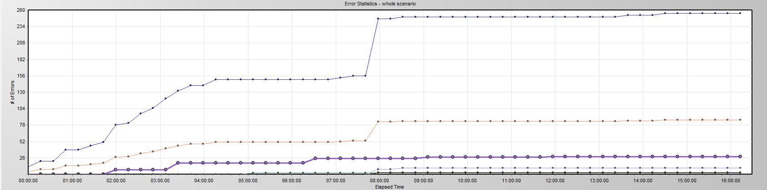

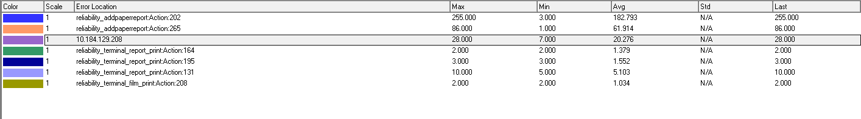

|  |  |  |
| --- | --- | --- |
| No | description | Counts |
| 1 | "HttpSendRequest" failed, Windows error code=12002 and retry limit (0) exceeded for URL="http://10.184.129.208/NotifyServer/NotifyService.asmx" | 85 |
| 2 | No match found for the requested parameter "ServiceResult". Check whether the requested boundaries exist in the response data. Also, if the data you want to save exceeds 256 bytes, use web\_set\_max\_html\_param\_len to increase the parameter size | 85 |
| 3 | The above "not found" error(s) may be explained by header and body byte counts being 0 and 0, respectively. | 85 |
| 4 | Add patient reports failed by using NotifyReportFile service, please reference the service is works well or not. The accn is A\*\*\*\*\*\*\*\*\*\* | 88 |
| 5 | Error -- memory violation : Exception ACCESS\_VIOLATION received. | 15 |

Error analyzes:

1. Http request do not execute successfully, need team to identify the reason of that. It may be caused by the lock or service error.
2. There is no response come from the PS service, perhaps caused by the IIS services.
3. Same as step2.
4. The services do not return the excepted response content, the service is down or the expiation catch function does not work.
5. Cause by the test tool, not error.

## Test Conclusion

Developer team has made some enhance works on this tested version for PS system. Reference the performance test result, the performance and reliability has enhanced. But there are still exist these issues need to update.

1. The “NotifyService” service needs to enhance. There are 86 transactions failed during the testing work. It will be the victims of the dead lock from database. We indentify the detail information from the log file:

2017-07-16 16:40:52,773 FATAL - ----------Exception----------

事务(进程 ID 139)与另一个进程被死锁在 锁 | 通信缓冲区 资源上，并且已被选作死锁牺牲品。请重新运行该事务。

在 System.Data.SqlClient.SqlConnection.OnError(SqlException exception, Boolean breakConnection, Action`1 wrapCloseInAction)

在 System.Data.SqlClient.TdsParser.ThrowExceptionAndWarning(TdsParserStateObject stateObj, Boolean callerHasConnectionLock, Boolean asyncClose)

在 System.Data.SqlClient.TdsParser.TryRun(RunBehavior runBehavior, SqlCommand cmdHandler, SqlDataReader dataStream, BulkCopySimpleResultSet bulkCopyHandler, TdsParserStateObject stateObj, Boolean& dataReady)

在 System.Data.SqlClient.SqlCommand.RunExecuteNonQueryTds(String methodName, Boolean async, Int32 timeout, Boolean asyncWrite)

在 System.Data.SqlClient.SqlCommand.InternalExecuteNonQuery(TaskCompletionSource`1 completion, String methodName, Boolean sendToPipe, Int32 timeout, Boolean asyncWrite)

在 System.Data.SqlClient.SqlCommand.ExecuteNonQuery()

在 BaseComponent.DBUtility.ExecuteSql(String db\_name, String sql) at:BaseComponent.PrintUtility.UpdatePaitentInfo-Line:0

1. There are many waits and locks exist in the database. We need update these issues as first. The detail SQL statement, please reference the performance testing reports.

We execute the whole testing works for 16 hours, it do not meet the requirements of test plan. Because the team has the plan to fix the performance issues first, the current version is not the final test one. Follow current test result, our core function module is not reliable. Sometimes it will fail caused by the deadlock:

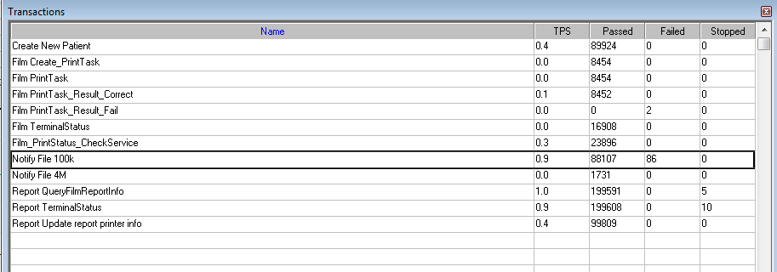

Whatever, we have made some progress on performance and reliability works. It confirms that the tuning operations are worked; team should keep going on it.

After team finish the performance tuning works, we will continue the reliability testing works. The result of reliability testing works is failed because it does not meet the requirement as current version.

# Testing work （Phase 2）

## Strategy and Scenario Setting

1. Use automation tool simulate the doctor print film work. Simulate 6 GX Platform by using QTP and PDSender tool. Each client prints one film which size is 10MB every 30 seconds.
2. Use LR tool simulate 8 K2/K3 terminals to print film. Each client prints one film which size is 10MB random 60 to 120 seconds.
3. Use LR tool simulate 10 PUMA terminals to print paper reports. Each client prints report random 60 to 120 seconds.
4. Use LR tool simulate 20 users to execute PUMA report archive operations. Each client archive report in random 60 to 90 seconds and size is random with 100kb and 4Mb.
5. The OCR setting is cover the rule for GX platforms in step1 and other setting are set as default.
6. Execute QTP script to print 100 patient`s report as cycle on a real terminal.
7. Monitor the hardware resource usage on PS.
8. Monitor the resource usage for database on PS.
9. Start/Stop 2 virtual users every 5 seconds and run the scenario for 7\*24 hours.

## Background Data

We use SQL command statement to add large data in the database, the detail information as follow:

|  |  |
| --- | --- |
| **Table Name** | **Data Volume (records)** |
| printer.dbo.DeliveryJob | 896813 |
| printer.dbo.ImageBox | 997879 |
| printer.dbo.Page | 997813 |
| printer.dbo.Session | 1001132 |
| wggc.dbo.Patient | 1029777 |
| wggc.dbo.Study | 1029789 |
| wggc.dbo.AFP\_PrintTerminalInfo | 62 |
| wggc.dbo.Series | 1029735 |
| wggc.dbo.Image | 1029738 |
| wggc.dbo.AFP\_FilmInfo | 1043592 |
| wggc.dbo.AFP\_ReportInfo | 936761 |
| wggc.dbo.AFP\_ExamInfo | 1997005 |
| wggc.dbo.AFP\_PrintTask | 3696324 |
| wggc.dbo.T\_Integration\_ExamInfo | 119292 |
| AFP\_PrintMode | 87883 |
| wggc.dbo.vi\_KIOSK\_ExamInfo\_Order | 119331 |

Figure 4.2.1 Background Data

## Other Setting:

### Database setting

Memory: Set the min and max memory size to 8GB.

Index fill factor: 80.

File: Increase the data and log files size and the rule is increase 500Mb as fixed size.

### IIS setting

Connection: Keep with setting which change by the PS install package.

## Test Object version

KIOSK Platform 3.0.0.1 B09

## Test result

### Test Statistic Report

|  |  |
| --- | --- |
| Analysis Summary | Period: 2017/8/1 12:57 - 2017/8/2 10:06 |

|  |  |
| --- | --- |
| **Scenario Name:** | E:\ECS\Performance\Script\208\ScenarioPUMA\_Reliability.lrs |
| **Results in Session:** | C:\Users\Administrator\AppData\Local\Temp\res\res.lrr |
| **Duration:** | 21 hours, 8 minutes and 39 seconds. |

|  |
| --- |
| Statistics Summary |

|  |  |  |
| --- | --- | --- |
| [**Maximum Running Vusers:**](file:///C:\Users\Administrator\Desktop\Relalibility\reliability_20170802\VuserStateGraph) |  | 38 |
| [**Total Throughput (bytes):**](file:///C:\Users\Administrator\Desktop\Relalibility\reliability_20170802\Throughput) | [Show SLA Results](slarules:total_throughput) | 40,621,257 |
| [**Average Throughput (bytes/second):**](file:///C:\Users\Administrator\Desktop\Relalibility\reliability_20170802\Throughput) | [Show SLA Results](slarules:average_throughput) | 534 |
| [**Total Hits:**](file:///C:\Users\Administrator\Desktop\Relalibility\reliability_20170802\HitsperSecond) | [Show SLA Results](slarules:total_hits) | 83,325 |
| [**Average Hits per Second:**](file:///C:\Users\Administrator\Desktop\Relalibility\reliability_20170802\HitsperSecond) | [Show SLA Results](slarules:average_hits) | 1.095 | [**View HTTP Responses Summary**](file:///C:\Users\Administrator\Desktop\Relalibility\reliability_20170802\reliability_20170802.html#1) |
| [**Total Errors:**](file:///C:\Users\Administrator\Desktop\Relalibility\reliability_20170802\TotalErrorsPerSecond) | [Show SLA Results](slarules:errors_per_second) | 204 |  |

|  |  |  |
| --- | --- | --- |
| |  | | --- | | You can define SLA data using the [SLA configuration wizard](slaconfig:) | | You can analyze transaction behavior using the [Analyze Transaction mechanism](analyze:) | |

|  |
| --- |
| Transaction Summary |

|  |  |  |  |  |
| --- | --- | --- | --- | --- |
| [**Transactions:**](file:///C:\Users\Administrator\Desktop\Relalibility\reliability_20170802\TransactionSummary) | Total Passed: 117,621 | Total Failed: 204 | Total Stopped: 0 | [**Average Response Time**](file:///C:\Users\Administrator\Desktop\Relalibility\reliability_20170802\ResponseTime) |

|  |  |  |  |  |  |  |  |  |  |
| --- | --- | --- | --- | --- | --- | --- | --- | --- | --- |
| **Transaction Name** | **SLA Status** | **Minimum** | **Average** | **Maximum** | **Std. Deviation** | **90 Percent** | **Pass** | **Fail** | **Stop** |
| [Create New Patient](file:///C:\Users\Administrator\Desktop\Relalibility\reliability_20170802\ResponseTime0000(Create%20New%20Patient)0000) | [Show SLA Results](slarules:transaction_response_time_CreateNewPatient) | 0.203 | 0.299 | 5.242 | 0.119 | 0.424 | 17,649 | 0 | 0 |
| [Film Create\_PrintTask](file:///C:\Users\Administrator\Desktop\Relalibility\reliability_20170802\ResponseTime0000(Film%20Create_PrintTask)0000) | [Show SLA Results](slarules:transaction_response_time_FilmCreate_PrintTask) | 0 | 0.053 | 16.879 | 0.259 | 0.094 | 4,443 | 0 | 0 |
| [Film PrintTask](file:///C:\Users\Administrator\Desktop\Relalibility\reliability_20170802\ResponseTime0000(Film%20PrintTask)0000) | [Show SLA Results](slarules:transaction_response_time_FilmPrintTask) | 0.016 | 0.089 | 30.529 | 0.466 | 0.14 | 4,443 | 0 | 0 |
| [Film PrintTask\_Result\_Correct](file:///C:\Users\Administrator\Desktop\Relalibility\reliability_20170802\ResponseTime0000(Film%20PrintTask_Result_Correct)0000) | [Show SLA Results](slarules:transaction_response_time_FilmPrintTask_Result_Correct) | 0 | 0 | 0.016 | 0.001 | 0 | 4,439 | 0 | 0 |
| [Film PrintTask\_Result\_Fail](file:///C:\Users\Administrator\Desktop\Relalibility\reliability_20170802\ResponseTime0000(Film%20PrintTask_Result_Fail)0000) | [Show SLA Results](slarules:transaction_response_time_FilmPrintTask_Result_Fail) | 0 | 0 | 0 | 0 | 0 | 0 | 4 | 0 |
| [Film TerminalStatus](file:///C:\Users\Administrator\Desktop\Relalibility\reliability_20170802\ResponseTime0000(Film%20TerminalStatus)0000) | [Show SLA Results](slarules:transaction_response_time_FilmTerminalStatus) | 0 | 0.045 | 4.134 | 0.067 | 0.078 | 8,886 | 0 | 0 |
| [Film\_PrintStatus\_CheckService](file:///C:\Users\Administrator\Desktop\Relalibility\reliability_20170802\ResponseTime0000(Film_PrintStatus_CheckService)0000) | [Show SLA Results](slarules:transaction_response_time_Film_PrintStatus_CheckService) | 0 | 0.046 | 30.389 | 0.367 | 0.078 | 12,650 | 0 | 0 |
| [Notify File 100k](file:///C:\Users\Administrator\Desktop\Relalibility\reliability_20170802\ResponseTime0000(Notify%20File%20100k)0000) | [Show SLA Results](slarules:transaction_response_time_NotifyFile100k) | 0.156 | 0.788 | 22.261 | 1.312 | 0.952 | 17,086 | 181 | 0 |
| [Notify File 4M](file:///C:\Users\Administrator\Desktop\Relalibility\reliability_20170802\ResponseTime0000(Notify%20File%204M)0000) | [Show SLA Results](slarules:transaction_response_time_NotifyFile4M) | 0.203 | 0.861 | 12.308 | 1.2 | 1.17 | 380 | 2 | 0 |
| [Report Print Task Correct](file:///C:\Users\Administrator\Desktop\Relalibility\reliability_20170802\ResponseTime0000(Report%20%20Print%20Task%20Correct)0000) | [Show SLA Results](slarules:transaction_response_time_ReportPrintTaskCorrect) | 0 | 0 | 0.001 | 0 | 0 | 5,224 | 0 | 0 |
| [Report Print Task fail](file:///C:\Users\Administrator\Desktop\Relalibility\reliability_20170802\ResponseTime0000(Report%20%20Print%20Task%20fail)0000) | [Show SLA Results](slarules:transaction_response_time_ReportPrintTaskfail) | 0 | 0 | 0 | 0 | 0 | 0 | 17 | 0 |
| [Report Create\_PrintTask](file:///C:\Users\Administrator\Desktop\Relalibility\reliability_20170802\ResponseTime0000(Report%20Create_PrintTask)0000) | [Show SLA Results](slarules:transaction_response_time_ReportCreate_PrintTask) | 0 | 0.049 | 11.107 | 0.174 | 0.094 | 5,241 | 0 | 0 |
| [Report PrintTask](file:///C:\Users\Administrator\Desktop\Relalibility\reliability_20170802\ResponseTime0000(Report%20PrintTask)0000) | [Show SLA Results](slarules:transaction_response_time_ReportPrintTask) | 0.016 | 0.083 | 2.967 | 0.109 | 0.14 | 5,241 | 0 | 0 |
| [Report PrintTask Status Check](file:///C:\Users\Administrator\Desktop\Relalibility\reliability_20170802\ResponseTime0000(Report%20PrintTask%20Status%20Check)0000) | [Show SLA Results](slarules:transaction_response_time_ReportPrintTaskStatusCheck) | 0 | 0.049 | 21.528 | 0.291 | 0.094 | 5,734 | 0 | 0 |
| [Report QueryFilmReportInfo](file:///C:\Users\Administrator\Desktop\Relalibility\reliability_20170802\ResponseTime0000(Report%20QueryFilmReportInfo)0000) | [Show SLA Results](slarules:transaction_response_time_ReportQueryFilmReportInfo) | 0 | 0.018 | 0.546 | 0.027 | 0.047 | 5,241 | 0 | 0 |
| [Report TerminalStatus](file:///C:\Users\Administrator\Desktop\Relalibility\reliability_20170802\ResponseTime0000(Report%20TerminalStatus)0000) | [Show SLA Results](slarules:transaction_response_time_ReportTerminalStatus) | 0 | 0.044 | 7.466 | 0.098 | 0.078 | 10,482 | 0 | 0 |
| [Report Update PrintTask](file:///C:\Users\Administrator\Desktop\Relalibility\reliability_20170802\ResponseTime0000(Report%20Update%20PrintTask)0000) | [Show SLA Results](slarules:transaction_response_time_ReportUpdatePrintTask) | 0.016 | 0.116 | 5.959 | 0.134 | 0.203 | 5,241 | 0 | 0 |
| [Report Update report printer info](file:///C:\Users\Administrator\Desktop\Relalibility\reliability_20170802\ResponseTime0000(Report%20Update%20report%20printer%20info)0000) | [Show SLA Results](slarules:transaction_response_time_ReportUpdatereportprinterinfo) | 0.027 | 0.086 | 2.711 | 0.1 | 0.14 | 5,241 | 0 | 0 |

|  |  |  |  |  |  |  |
| --- | --- | --- | --- | --- | --- | --- |
| **Service Level Agreement Legend:** | C:\Users\Administrator\Desktop\Relalibility\reliability_20170802\led_ok.gif | Pass | C:\Users\Administrator\Desktop\Relalibility\reliability_20170802\led_error.gif | Fail | C:\Users\Administrator\Desktop\Relalibility\reliability_20170802\led_no_data.gif | No Data |

|  |
| --- |
| HTTP Responses Summary |

|  |  |  |
| --- | --- | --- |
| **HTTP Responses** | **Total** | **Per second** |
| [HTTP\_200](file:///C:\Users\Administrator\Desktop\Relalibility\reliability_20170802\HttpReturnCodes0001(HTTP_200)0001) | 83,325 | 1.095 |

Figure 4.5.1.1 Summary Report

Follow the result information, we can get that there are some transactions failed during the testing work. We will analysis the reason in other chapters.

### Transaction summary result

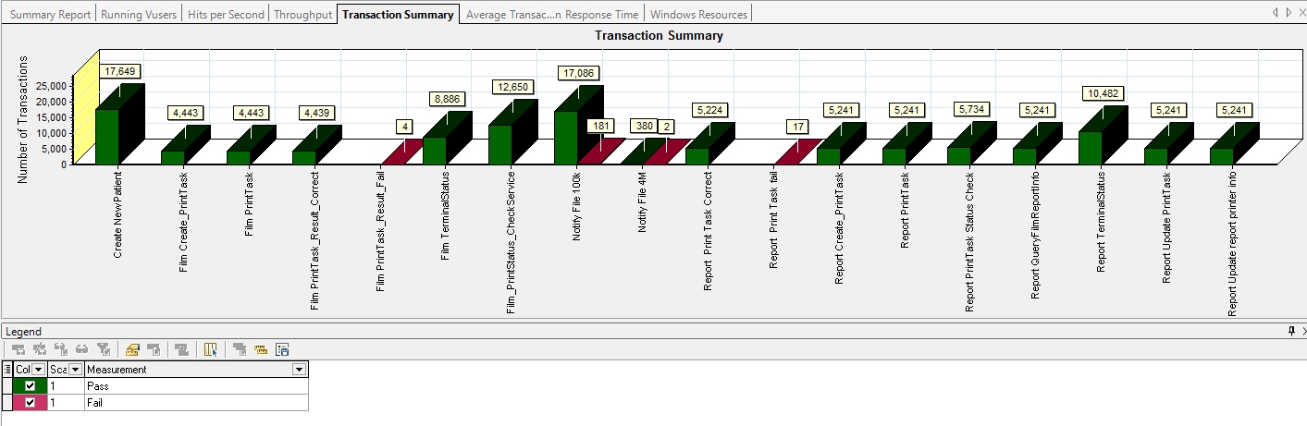

Figure 3.5.2.1 Transaction Summary

We can notice that there are some transactions failed during the testing work. We should find out the reason and fix it in the next version.

### Transaction response time result

We can get the transaction response time information from the figure as follow:

|  |
| --- |
| Average Transaction Response Time Graph |
| |  |  |  |  |  |  |  |  | | --- | --- | --- | --- | --- | --- | --- | --- | | **Color** | **Scale** | **Measurement** | **Graph's Minimum** | **Graph's Average** | **Graph's Maximum** | **Graph's Median** | **Graph's Std. Deviation** | |  | 1 | Create New Patient | 0.276 | 0.299 | 0.375 | 0.289 | 0.023 | |  | 1 | Film Create\_PrintTask | 0.036 | 0.053 | 0.204 | 0.046 | 0.027 | |  | 1 | Film PrintTask | 0.059 | 0.089 | 0.366 | 0.078 | 0.049 | |  | 1 | Film PrintTask\_Result\_Correct | 0 | 0 | 0 | 0 | 0 | |  | 1 | Film TerminalStatus | 0.033 | 0.045 | 0.087 | 0.041 | 0.011 | |  | 1 | Film\_PrintStatus\_CheckService | 0.032 | 0.046 | 0.218 | 0.037 | 0.03 | |  | 1 | Notify File 100k | 0.52 | 0.786 | 1.433 | 0.746 | 0.166 | |  | 1 | Notify File 4M | 0.433 | 0.83 | 2.266 | 0.653 | 0.444 | |  | 1 | Report Print Task Correct | 0 | 0 | 0 | 0 | 0 | |  | 1 | Report Create\_PrintTask | 0.034 | 0.049 | 0.172 | 0.044 | 0.023 | |  | 1 | Report PrintTask | 0.053 | 0.082 | 0.167 | 0.082 | 0.021 | |  | 1 | Report PrintTask Status Check | 0.028 | 0.046 | 0.184 | 0.04 | 0.025 | |  | 1 | Report QueryFilmReportInfo | 0.007 | 0.018 | 0.043 | 0.016 | 0.009 | |  | 1 | Report TerminalStatus | 0.032 | 0.044 | 0.122 | 0.039 | 0.016 | |  | 1 | Report Update PrintTask | 0.091 | 0.116 | 0.192 | 0.107 | 0.024 | |  | 1 | Report Update report printer info | 0.068 | 0.086 | 0.177 | 0.08 | 0.022 | |
|  |
|  |
| C:\Users\Administrator\Desktop\Relalibility\reliability_20170802\Report\dot_trans.gif |
|  |
| |  | | --- | | **Description:**Displays the average time taken to perform transactions during each second of the load test. This graph helps you determine whether the performance of the server is within acceptable minimum and maximum transaction performance time ranges defined for your system. | |
|  |
|  |

Figure 4.5.3.1 Transaction response time

This figure information shows all transactions` response time. The transaction times are all meets the requirements, we should focus on the transaction pass percentage.

## Bottleneck analysis

### Hardware usage analysis

During the testing work, we use the test tool to monitor the server hardware usage include the CPU, Memory, hard disk and etc.

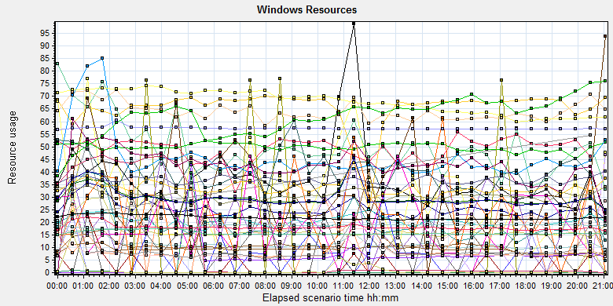

C:\Users\Administrator\AppData\Local\Temp\Report\dot_trans.gif

|  |  |  |  |  |  |  |
| --- | --- | --- | --- | --- | --- | --- |
| **Color** | **Scale** | **Measurement** | **Minimum** | **Average** | **Maximum** | **Std. Deviation** |
|  | 0.1 | % Disk Read Time (PhysicalDisk \_Total):10.184.129.208 | 0 | 11.88 | 18499.111 | 286.754 |
|  | 0.1 | % Disk Time (PhysicalDisk \_Total):10.184.129.208 | 8.091 | 90.264 | 22511.539 | 340.579 |
|  | 0.1 | % Disk Write Time (PhysicalDisk \_Total):10.184.129.208 | 7.673 | 78.384 | 5461.341 | 107.751 |
|  | 1 | % Idle Time (PhysicalDisk \_Total):10.184.129.208 | 0 | 65.242 | 95.967 | 18.54 |
|  | 1000 | % Interrupt Time (Processor \_Total):10.184.129.208 | 0 | 0.025 | 0.347 | 0.037 |
|  | 10 | % Privileged Time (Processor \_Total):10.184.129.208 | 0 | 1.154 | 10.665 | 0.841 |
|  | 10 | % Processor Time (Process AcquisitionServer):10.184.129.208 | 0 | 1.024 | 32.642 | 2.939 |
|  | 10000 | % Processor Time (Process auditServer):10.184.129.208 | 0 | 0.001 | 0.524 | 0.026 |
|  | 10 | % Processor Time (Process AutoDeliveryServer):10.184.129.208 | 0 | 1.66 | 42.187 | 5.303 |
|  | 1000 | % Processor Time (Process AutoForwardFilmService):10.184.129.208 | 0 | 0.018 | 1.058 | 0.097 |
|  | 10000 | % Processor Time (Process JP2MngSrv):10.184.129.208 | 0 | 0 | 1.036 | 0.013 |
|  | 10000 | % Processor Time (Process Kiosk.Alarm.KService):10.184.129.208 | 0 | 0.003 | 3.646 | 0.047 |
|  | 1000 | % Processor Time (Process LogServer):10.184.129.208 | 0 | 0.05 | 2.083 | 0.18 |
|  | 1 | % Processor Time (Process Ltthunkserver#1):10.184.129.208 | 0 | 48.758 | 113.472 | 27.404 |
|  | 1 | % Processor Time (Process Ltthunkserver#2):10.184.129.208 | 0 | 39.835 | 88.083 | 29.838 |
|  | 1 | % Processor Time (Process Ltthunkserver):10.184.129.208 | 0 | 49.874 | 250.259 | 28.67 |
|  | 1000 | % Processor Time (Process MessageQueue):10.184.129.208 | 0 | 0.037 | 2.604 | 0.151 |
|  | 100000 | % Processor Time (Process OamServer):10.184.129.208 | 0 | 0 | 0.521 | 0.007 |
|  | 1 | % Processor Time (Process OcrService):10.184.129.208 | 0 | 19.343 | 246.114 | 32.814 |
|  | 10000 | % Processor Time (Process PDCSenderServer):10.184.129.208 | 0 | 0.001 | 0.526 | 0.018 |
|  | 100 | % Processor Time (Process PrinterMonitor):10.184.129.208 | 0 | 0.206 | 4.158 | 0.405 |
|  | 100 | % Processor Time (Process PrintScheduler):10.184.129.208 | 0 | 0.64 | 9.845 | 0.975 |
|  | 100 | % Processor Time (Process PrintSCPServer):10.184.129.208 | 0 | 0.457 | 19.271 | 1.72 |
|  | 10000 | % Processor Time (Process PrintServer):10.184.129.208 | 0 | 0.003 | 1.04 | 0.04 |
|  | 10000 | % Processor Time (Process PSNotificationService):10.184.129.208 | 0 | 0.002 | 1.036 | 0.032 |
|  | 10000 | % Processor Time (Process RequestServer):10.184.129.208 | 0 | 0 | 0.521 | 0.007 |
|  | 10000 | % Processor Time (Process RuleServer):10.184.129.208 | 0 | 0.002 | 0.529 | 0.034 |
|  | 0.1 | % Processor Time (Process sqlservr):10.184.129.208 | 6.736 | 297.843 | 1083.206 | 149.771 |
|  | 10000 | % Processor Time (Process sqlwriter):10.184.129.208 | 0 | 0 | 0.521 | 0.011 |
|  | 10000 | % Processor Time (Process SSCPServer):10.184.129.208 | 0 | 0.002 | 1.042 | 0.033 |
|  | 10000 | % Processor Time (Process TaskManager):10.184.129.208 | 0 | 0.001 | 1.042 | 0.024 |
|  | 100 | % Processor Time (Process Taskmgr):10.184.129.208 | 0 | 0.432 | 11.399 | 0.722 |
|  | 100 | % Processor Time (Process w3wp#1):10.184.129.208 | 0 | 0.306 | 7.936 | 0.477 |
|  | 1000 | % Processor Time (Process w3wp#2):10.184.129.208 | 0 | 0.04 | 4.663 | 0.163 |
|  | 100 | % Processor Time (Process w3wp#3):10.184.129.208 | 0 | 0.366 | 16.062 | 1.92 |
|  | 1 | % Processor Time (Process w3wp#4):10.184.129.208 | 0 | 5.721 | 26551.016 | 167.336 |
|  | 1 | % Processor Time (Process w3wp#5):10.184.129.208 | 0 | 1.218 | 26827.097 | 168.721 |
|  | 10 | % Processor Time (Process w3wp#6):10.184.129.208 | 0 | 2.057 | 21.875 | 3.021 |
|  | 100 | % Processor Time (Process w3wp):10.184.129.208 | 0 | 0.335 | 6.25 | 0.48 |
|  | 1 | % Processor Time (Processor \_Total):10.184.129.208 | 0.825 | 29.886 | 98.316 | 14.548 |
|  | 0.001 | Available MBytes (Memory):10.184.129.208 | 17173 | 18567.082 | 20091 | 605.414 |
|  | 0.0001 | Avg. Disk Bytes/Transfer (PhysicalDisk \_Total):10.184.129.208 | 3848.828 | 104311.322 | 1128038.4 | 139280.272 |
|  | 10 | Avg. Disk Queue Length (PhysicalDisk \_Total):10.184.129.208 | 0.081 | 0.903 | 225.115 | 3.406 |
|  | 10 | Avg. Disk Read Queue Length (PhysicalDisk \_Total):10.184.129.208 | 0 | 0.119 | 184.991 | 2.868 |
|  | 10 | Avg. Disk Write Queue Length (PhysicalDisk \_Total):10.184.129.208 | 0.077 | 0.784 | 54.613 | 1.077 |
|  | 0.001 | Bytes Total/sec (Server):10.184.129.208 | 51510.878 | 57271.648 | 73624.205 | 1173.155 |
|  | 1E-06 | Cache Bytes (Memory):10.184.129.208 | 56950784 | 68031512.383 | 86413312 | 4942063.695 |
|  | 1E-09 | Committed Bytes (Memory):10.184.129.208 | 13896966144 | 15795088383.919 | 17536094208 | 773027067.699 |
|  | 0.001 | Context Switches/sec (System):10.184.129.208 | 3007.766 | 18021.907 | 159516.02 | 7009.358 |
|  | 10 | Current Disk Queue Length (PhysicalDisk \_Total):10.184.129.208 | 0 | 0.921 | 213 | 3.791 |
|  | 0.01 | Threads (Objects):10.184.129.208 | 3191 | 6177.678 | 7983 | 763.938 |
|  | 0.01 | Threads (System):10.184.129.208 | 1995 | 2184.882 | 2637 | 88.518 |

C:\Users\Administrator\Desktop\Relalibility\reliability_20170802\Report\dot_trans.gif

Follow this information we can get that:

The CPU usage do not exist bottleneck, the process time is 30-40% (*% Processor Time (Processor \_Total)*). CPU resources do not have stress.

The memory available value is 18.5G and the system use 1.5 G. The memory do not has bottleneck under current testing stress.

The disk read and writes stress is also small; do not find the disk bottleneck.

### SQL Server resource usage analysis

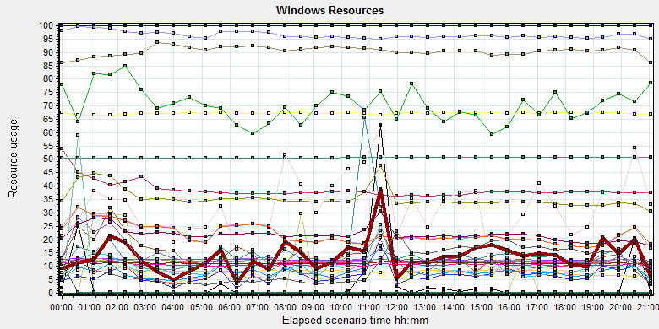

|  |  |  |  |  |  |  |  |  |  |  |  |  |  |  |  |  |  |  |  |  |  |  |  |  |  |  |  |  |  |  |  |  |  |  |  |  |  |  |  |  |  |  |  |  |  |  |  |  |  |  |  |  |  |  |  |  |  |  |  |  |  |  |  |  |  |  |  |  |  |  |  |  |  |  |  |  |  |  |  |  |  |  |  |  |  |  |  |  |  |  |  |  |  |  |  |  |  |  |  |  |  |  |  |  |  |  |  |  |  |  |  |  |  |  |  |  |  |  |  |  |  |  |  |  |  |  |  |  |  |  |  |  |  |  |  |  |  |  |  |  |  |  |  |  |  |  |  |  |  |  |  |  |  |  |  |  |  |  |  |  |  |  |  |  |  |  |  |  |  |  |  |  |  |  |  |  |  |  |  |  |  |  |  |  |  |  |  |  |  |  |  |  |  |  |  |  |  |  |  |  |  |  |  |  |  |  |  |  |  |  |  |  |  |  |  |  |  |  |  |  |  |  |  |  |  |  |  |  |  |  |  |  |  |  |  |  |  |  |  |  |  |  |  |  |  |  |  |
| --- | --- | --- | --- | --- | --- | --- | --- | --- | --- | --- | --- | --- | --- | --- | --- | --- | --- | --- | --- | --- | --- | --- | --- | --- | --- | --- | --- | --- | --- | --- | --- | --- | --- | --- | --- | --- | --- | --- | --- | --- | --- | --- | --- | --- | --- | --- | --- | --- | --- | --- | --- | --- | --- | --- | --- | --- | --- | --- | --- | --- | --- | --- | --- | --- | --- | --- | --- | --- | --- | --- | --- | --- | --- | --- | --- | --- | --- | --- | --- | --- | --- | --- | --- | --- | --- | --- | --- | --- | --- | --- | --- | --- | --- | --- | --- | --- | --- | --- | --- | --- | --- | --- | --- | --- | --- | --- | --- | --- | --- | --- | --- | --- | --- | --- | --- | --- | --- | --- | --- | --- | --- | --- | --- | --- | --- | --- | --- | --- | --- | --- | --- | --- | --- | --- | --- | --- | --- | --- | --- | --- | --- | --- | --- | --- | --- | --- | --- | --- | --- | --- | --- | --- | --- | --- | --- | --- | --- | --- | --- | --- | --- | --- | --- | --- | --- | --- | --- | --- | --- | --- | --- | --- | --- | --- | --- | --- | --- | --- | --- | --- | --- | --- | --- | --- | --- | --- | --- | --- | --- | --- | --- | --- | --- | --- | --- | --- | --- | --- | --- | --- | --- | --- | --- | --- | --- | --- | --- | --- | --- | --- | --- | --- | --- | --- | --- | --- | --- | --- | --- | --- | --- | --- | --- | --- | --- | --- | --- | --- | --- | --- | --- | --- | --- | --- | --- | --- | --- | --- | --- | --- | --- | --- | --- | --- | --- | --- | --- |
| |  |  |  |  |  |  |  | | --- | --- | --- | --- | --- | --- | --- | | **Color** | **Scale** | **Measurement** | **Minimum** | **Average** | **Maximum** | **Std. Deviation** | |  | 0.1 | Batch Requests/sec (MSSQL$GCPACSWS|SQL Statistics):10.184.129.208 | 67.43 | 125.382 | 245.508 | 28.924 | |  | 1 | Buffer cache hit ratio (MSSQL$GCPACSWS|Buffer Manager):10.184.129.208 | 71.559 | 99.994 | 100 | 0.287 | |  | 1 | Cache Hit Ratio (MSSQL$GCPACSWS|Catalog Metadata WGGC):10.184.129.208 | 50.409 | 50.622 | 50.737 | 0.095 | |  | 0.0001 | Cursor memory usage (MSSQL$GCPACSWS|Cursor Manager by Type \_Total):10.184.129.208 | 355968 | 386503.436 | 570320 | 32597.144 | |  | 10 | Cursor Requests/sec (MSSQL$GCPACSWS|Cursor Manager by Type \_Total):10.184.129.208 | 0 | 0.834 | 14.275 | 1.432 | |  | 1 | Database Cache Size (MB) (Database svchost):10.184.129.208 | 0 | 0 | 0 | 0 | |  | 100 | Distributed Query (MSSQL$GCPACSWS|Exec Statistics Average execution time (ms)):10.184.129.208 | 0 | 0.139 | 40 | 0.729 | |  | 1 | Distributed Query (MSSQL$GCPACSWS|Exec Statistics Cumulative execution time (ms) per second):10.184.129.208 | 0 | 0 | 0 | 0 | |  | 10000 | Distributed Query (MSSQL$GCPACSWS|Exec Statistics Execs in progress):10.184.129.208 | 0 | 0 | 1 | 0.019 | |  | 1E-16 | Distributed Query (MSSQL$GCPACSWS|Exec Statistics Execs started per second):10.184.129.208 | 0 | 3.18852430986911E+17 | 1.84467440737095E+19 | 2.40418849488749E+18 | |  | 10 | Errors/sec (MSSQL$GCPACSWS|SQL Errors \_Total):10.184.129.208 | 0 | 9.653 | 49.454 | 2.601 | |  | 10 | Errors/sec (MSSQL$GCPACSWS|SQL Errors User Errors):10.184.129.208 | 0 | 6.726 | 10.296 | 1.936 | |  | 10000 | Extended Procedures (MSSQL$GCPACSWS|Exec Statistics Average execution time (ms)):10.184.129.208 | 0 | 0 | 2 | 0.018 | |  | 0.1 | Full Scans/sec (MSSQL$GCPACSWS|Access Methods):10.184.129.208 | 3.321 | 115.523 | 1813.87 | 105.566 | |  | 0.001 | Index Searches/sec (MSSQL$GCPACSWS|Access Methods):10.184.129.208 | 630.678 | 12194.694 | 76228.462 | 9831.729 | |  | 1000 | Latch waits/sec (MSOLAP$GCPACSWS|Locks):10.184.129.208 | 0 | 0.07 | 1.328 | 0.148 | |  | 1000 | Lazy writes/sec (MSSQL$GCPACSWS|Buffer Manager):10.184.129.208 | 0 | 0.004 | 30.225 | 0.206 | |  | 0.0001 | Lock Requests/sec (MSSQL$GCPACSWS|Locks \_Total):10.184.129.208 | 19878.123 | 355062.462 | 2509143.427 | 160089.583 | |  | 10 | Lock Timeouts/sec (MSSQL$GCPACSWS|Locks \_Total):10.184.129.208 | 0 | 1.521 | 1341.834 | 12.801 | |  | 0.01 | Lock Wait Time (ms) (MSSQL$GCPACSWS|Locks \_Total):10.184.129.208 | 0 | 666.648 | 121090.953 | 4594.466 | |  | 0.1 | Lock waits (MSSQL$GCPACSWS|Wait Statistics Average wait time (ms)):10.184.129.208 | 0 | 94.07 | 20471 | 580.135 | |  | 10 | Lock waits (MSSQL$GCPACSWS|Wait Statistics Waits in progress):10.184.129.208 | 0 | 0.817 | 76 | 3.974 | |  | 10 | Lock Waits/sec (MSSQL$GCPACSWS|Locks \_Total):10.184.129.208 | 0 | 0.787 | 52.121 | 2.366 | |  | 1 | Log write waits (MSSQL$GCPACSWS|Wait Statistics Average wait time (ms)):10.184.129.208 | 0 | 11.195 | 29 | 1.818 | |  | 0.1 | Logical Connections (MSSQL$GCPACSWS|General Statistics):10.184.129.208 | 90 | 106.73 | 140 | 7.274 | |  | 100 | Logins/sec (MSSQL$GCPACSWS|General Statistics):10.184.129.208 | 0 | 0.22 | 13.517 | 0.306 | |  | 100 | Logouts/sec (MSSQL$GCPACSWS|General Statistics):10.184.129.208 | 0 | 0.22 | 13.188 | 0.323 | |  | 1 | Lookups/sec (MSOLAP$GCPACSWS|Cache):10.184.129.208 | 0 | 0 | 0 | 0 | |  | 1000 | Number of Deadlocks/sec (MSSQL$GCPACSWS|Locks \_Total):10.184.129.208 | 0 | 0.014 | 2.655 | 0.09 | |  | 1 | OLEDB calls (MSSQL$GCPACSWS|Exec Statistics Average execution time (ms)):10.184.129.208 | 0 | 13.623 | 1211 | 26.61 | |  | 1 | Page IO latch waits (MSSQL$GCPACSWS|Wait Statistics Average wait time (ms)):10.184.129.208 | 0 | 10.208 | 570 | 21.247 | |  | 10 | Safe Auto-Params/sec (MSSQL$GCPACSWS|SQL Statistics):10.184.129.208 | 0 | 2.196 | 18.59 | 1.997 | |  | 1 | SQL Compilations/sec (MSSQL$GCPACSWS|SQL Statistics):10.184.129.208 | 59.126 | 90.587 | 189.242 | 9.457 | |  | 100 | SQL Re-Compilations/sec (MSSQL$GCPACSWS|SQL Statistics):10.184.129.208 | 0 | 0.005 | 30.403 | 0.247 |   C:\Users\Administrator\Desktop\Relalibility\reliability_20170802\Report\dot_trans.gif   |  | | --- | | **Description:**Displays a summary of the System Resources usage for each Windows based host. | |  | |

Figure 4.6.2.1 Database result

Follow the SQL server monitor resource, we can find the Database has some issues that make the system reliability not well:

There are cursors operations exist in the database:

|  |  |  |  |  |  |  |
| --- | --- | --- | --- | --- | --- | --- |
|  | 0.0001 | Cursor memory usage (MSSQL$GCPACSWS|Cursor Manager by Type \_Total):10.184.129.208 | 355968 | 386503.436 | 570320 | 32597.144 |
|  | 10 | Cursor Requests/sec (MSSQL$GCPACSWS|Cursor Manager by Type \_Total):10.184.129.208 | 0 | 0.834 | 14.275 | 1.432 |

Database does the cursor operations every 0.8/ seconds. SQL server suggests users to do the operation base on column data. Please indentify the SQL statement and do some enhance works.

There are some error happens during the testing work:

|  |  |  |  |  |  |  |
| --- | --- | --- | --- | --- | --- | --- |
|  | 10 | Errors/sec (MSSQL$GCPACSWS|SQL Errors \_Total):10.184.129.208 | 0 | 9.653 | 49.454 | 2.601 |
|  | 10 | Errors/sec (MSSQL$GCPACSWS|SQL Errors User Errors):10.184.129.208 | 0 | 6.726 | 10.296 | 1.936 |

Database has 9.6 errors every second and 6.7/ records are user errors. It maybe cause by the dead lock or other issues.

There are too many full scans operations exist in the database:

|  |  |  |  |  |  |  |
| --- | --- | --- | --- | --- | --- | --- |
|  | 0.1 | Full Scans/sec (MSSQL$GCPACSWS|Access Methods):10.184.129.208 | 3.321 | 115.523 | 1813.87 | 105.566 |

Database has full scans issues and average value is 115/sec. This issue will affect the SQL statement executes slowly because it does not use the index. Some operations will cause the full scans such as select count (\*), use <> and! =, use like fuzzy query and query from view etc. Please enhance the SQL statement performance ASAP.

There are many locks and deadlocks issues exist in the database:

|  |  |  |  |  |  |  |
| --- | --- | --- | --- | --- | --- | --- |
|  | 10 | Lock Timeouts/sec (MSSQL$GCPACSWS|Locks \_Total):10.184.129.208 | 0 | 1.521 | 1341.834 | 12.801 |
|  | 0.01 | Lock Wait Time (ms) (MSSQL$GCPACSWS|Locks \_Total):10.184.129.208 | 0 | 666.648 | 121090.953 | 4594.466 |
|  | 0.1 | Lock waits (MSSQL$GCPACSWS|Wait Statistics Average wait time (ms)):10.184.129.208 | 0 | 94.07 | 20471 | 580.135 |
|  | 10 | Lock waits (MSSQL$GCPACSWS|Wait Statistics Waits in progress):10.184.129.208 | 0 | 0.817 | 76 | 3.974 |
|  | 10 | Lock Waits/sec (MSSQL$GCPACSWS|Locks \_Total):10.184.129.208 | 0 | 0.787 | 52.121 | 2.366 |
|  | 1 | Log write waits (MSSQL$GCPACSWS|Wait Statistics Average wait time (ms)):10.184.129.208 | 0 | 11.195 | 29 | 1.818 |
|  | 1000 | Number of Deadlocks/sec (MSSQL$GCPACSWS|Locks \_Total):10.184.129.208 | 0 | 0.014 | 2.655 | 0.09 |
|  | 10 | Lock Timeouts/sec (MSSQL$GCPACSWS|Locks \_Total):10.184.129.208 | 0 | 1.521 | 1341.834 | 12.801 |

We can see that the average lock waits time is 0.094 seconds and timeouts average value is 1.5/seconds. There are 0.78 locks and 0.014 deadlocks every second. The database design is not well, the deadlocks makes many test transactions failed. We should find out them and fix it as the high level tasks.

There are about 106database connections in the database, but login and logout frequency is 0.22/sec. Can we reduce the connection number?

|  |  |  |  |  |  |  |
| --- | --- | --- | --- | --- | --- | --- |
|  | 0.1 | Logical Connections (MSSQL$GCPACSWS|General Statistics):10.184.129.208 | 90 | 106.73 | 140 | 7.274 |
|  | 100 | Logins/sec (MSSQL$GCPACSWS|General Statistics):10.184.129.208 | 0 | 0.22 | 13.517 | 0.306 |
|  | 100 | Logouts/sec (MSSQL$GCPACSWS|General Statistics):10.184.129.208 | 0 | 0.22 | 13.188 | 0.323 |

## Test Error

There are some errors exist in the testing work and logged as follow:

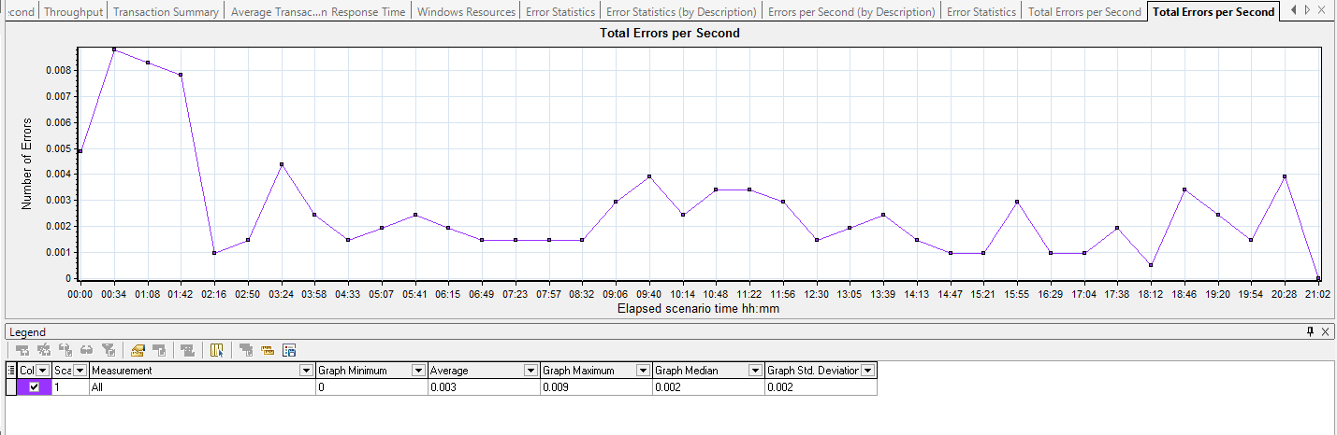

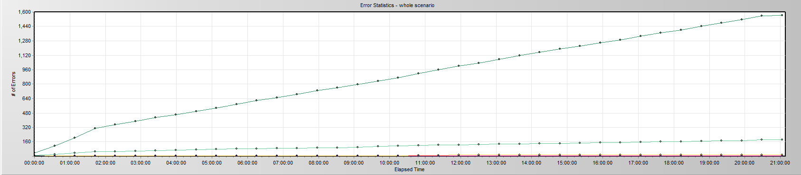

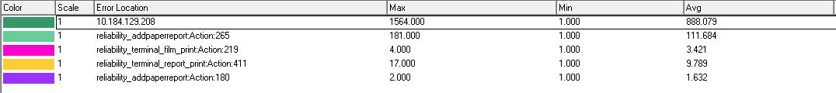

|  |  |  |
| --- | --- | --- |
| No | description | Counts |
| 1 | Windows Resources. Cannot access data for measurement Process|% Processor Time|Ltthunkserver on machine 10.184.129.208. | 4584 |
| 2 | Action.c(265): Error: Add patient reports failed by using NotifyReportFile service, please reference the service is works well or not. The accn is A20170801\*\*\*\*\*\*\* | 183 |
| 3 | Action.c(219): Error: The task do not finish correct: TaskID: \*\*\*\* From Terminal: \*\*\*\* (Film) | 4 |
| 4 | Action.c(411): Error: The report task print failed! taskID: \*\*\*\*\*\* From Terminal: Terminal\*\*\*\*\* (report) | 17 |
|  |  |  |

Error analyzes:

1. This error cause by the test tool, the process of ‘Ltthunkserver’ cannot find in the server. It is not error for our testing works.
2. This error happened when user wants to archived paper report by using Notifyreportfile services. We find the reason from the service log:

*2017-08-01 14:13:18,870 ERROR - Exam A20170801135832589 of patient P20170801135832589 is invalidate in RIS, it will be ignored at:NotifyService.NotifyService.NotifyReportInfo-Line:0*

It cause by the integration service, the service cannot find the patient in RIS system. But we can query out the patient information from database.

1. This error happened when user print the films from the virtual printer. There are 3 errors cause by the printer because it disconnects the network from server. Only one error is a real error.
2. This error happened when user want to print paper report during the testing work. It maybe cause by the multiple threads issue belong to print schedule services.

## Test Conclusion

We execute the whole testing works for 21 hours, 8 minutes and 39 seconds.

During the testing work, we archived large data in system:

|  |  |
| --- | --- |
| **Data** | **count** |
| wggc.dbo.AFP\_ReportInfo | 17466 |
| wggc.dbo.AFP\_FilmInfo | 8290 |
| wggc.dbo.AFP\_PrintTask | 10496 (include the print count 812 from terminal) |
| Printer.dbo.DeliveryJob | 7502 |

During the reliability testing work, we also simulate the report print works on real Client by using automation test tool and monitor the client resource usage. The detail test log as follow:



|  |  |  |  |  |
| --- | --- | --- | --- | --- |
| **Transaction** | **All** | **Pass** | **Failed** | **Percentage** |
| Print report from terminal | 812 | 806 | 6 | 99.26% |

PUMA process CPU usage:

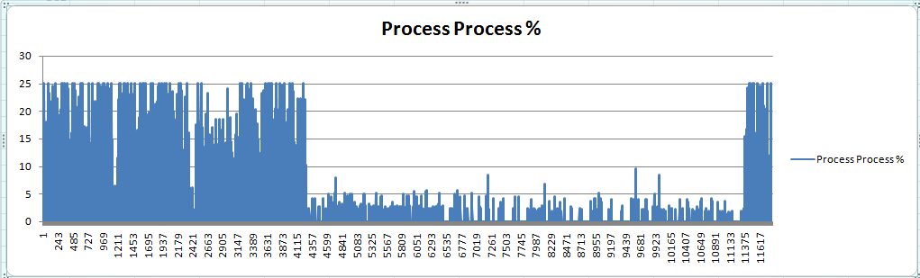

PUMA process MEMO Usage

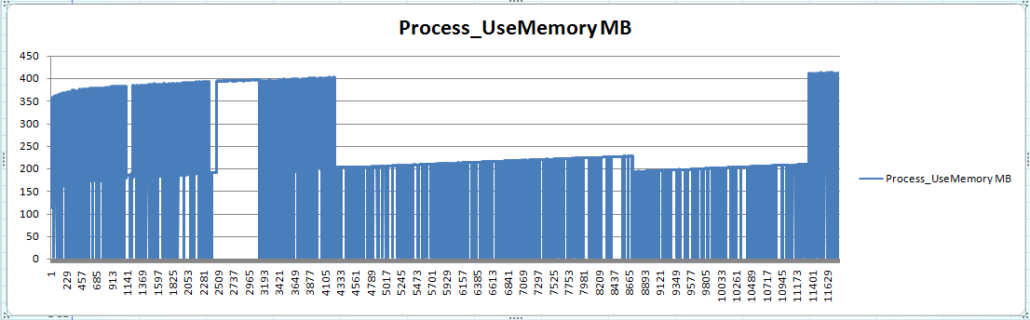

Client Memo Usage

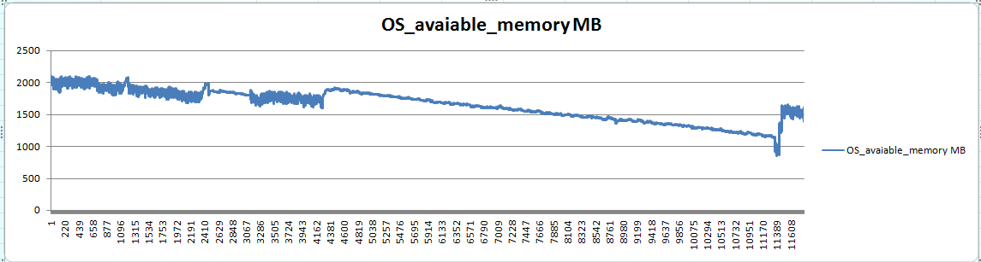

Client CPU usage:

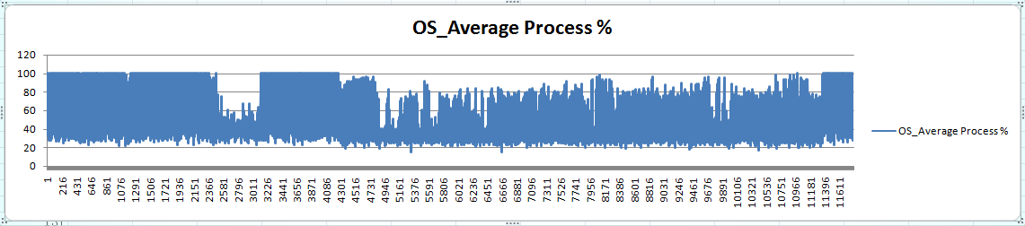

Follow the collect information, we can find that the stress in client is not very strong. The CPU usage is enough under the test tool and PUMA application stress.

The all transactions results as follow:

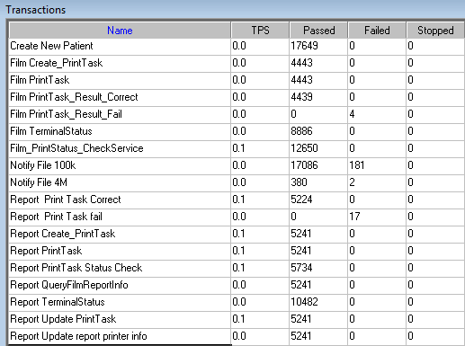

|  |  |  |  |  |
| --- | --- | --- | --- | --- |
| **Transaction** | **All** | **Pass** | **Failed** | **Percentage** |
| Report archived | 17649 | 17466 | 183 | 98.96% |
| Film Print | 4440 | 4439 | 1(3 not error) | 99.98% |
| Report Print | 5241 | 5224 | 17 | 99.68% |
|  |  |  |  |  |

We find that the report archived transaction do not meet the requirements (>=99%). Refer to the chapter test error, the reason is that the integration service has some lock or error. We view the integration service log file and find some errors as follow:

*[2017/08/02 00:13:52.827]:Function.SetPSExamInfo() Error Message = System.NullReferenceException: 未将对象引用设置到对象的实例。*

*在 KIOSK.Integration.WSProxy.Function.SetPSExamInfo(CExamInfo cei)*

*[2017/08/02 00:17:27.877]:Function.SetPrintMode() Error Message = System.IO.IOException: 文件“E:\KIOSK.Integration\Log\WSProxy\2017-08-02.00debug.log”正由另一进程使用，因此该进程无法访问此文件。*

*在 System.IO.\_\_Error.WinIOError(Int32 errorCode, String maybeFullPath)*

*在 System.IO.FileStream.Init(String path, FileMode mode, FileAccess access, Int32 rights, Boolean useRights, FileShare share, Int32 bufferSize, FileOptions options, SECURITY\_ATTRIBUTES secAttrs, String msgPath, Boolean bFromProxy, Boolean useLongPath, Boolean checkHost)*

*在 System.IO.FileStream..ctor(String path, FileMode mode, FileAccess access, FileShare share, Int32 bufferSize, FileOptions options, String msgPath, Boolean bFromProxy, Boolean useLongPath, Boolean checkHost)*

*在 System.IO.StreamWriter..ctor(String path, Boolean append, Encoding encoding, Int32 bufferSize, Boolean checkHost)*

*在 System.IO.StreamWriter..ctor(String path, Boolean append, Encoding encoding, Int32 bufferSize)*

*在 System.IO.StreamWriter..ctor(String path, Boolean append)*

*在 KIOSK.Integration.Log.LogFile.WriteLog(LogInfo logInfo)*

*在 KIOSK.Integration.Log.LogUtil.DebugLog(String strLogMessage)*

*在 KIOSK.Integration.WSProxy.Function.SetPrintMode(String strAccessionNumber, String strStudyInstanceUID, Int32 iPrintMode)*

*2017-08-01 14:13:18,870 ERROR - Exam A20170801135832589 of patient P20170801135832589 is invalidate in RIS, it will be ignored at:NotifyService.NotifyService.NotifyReportInfo-Line:0*

It seems the integration service has the queue jam for write log. May be it will cause the dead lock in the database. The service will lost the query result during the testing works, it also will cause the transactions failed.

After 2 phase testing works, the reliability of PUMA has enhanced. But it still not meets the requirements we have decided. We consider the reason is because the integration service concurrency is not well. We can find some errors in its logs and there is no index for its database table.

We will discuss the resolve solution with integration team and continue our system to meet the requirement. Develop team has enhance the ability of the report print module. The testing works will continue after we get the solution or has new version of PUMA product. We are very close for the successful.

# Testing work （Phase 3）

## Strategy and Scenario Setting

1. Use automation tool simulate the doctor print film work. Simulate 6 GX Platform by using QTP and PDSender tool. Each client prints one film which size is 10MB every 30 seconds.
2. Use LR tool simulate 8 K2/K3 terminals to print film. Each client prints one film which size is 10MB random 60 to 120 seconds.
3. Use LR tool simulate 10 PUMA terminals to print paper reports. Each client prints report random 60 to 120 seconds.
4. Use LR tool simulate 20 users to execute PUMA report archive operations. Each client archive report in random 60 to 90 seconds and size is random with 100kb and 4Mb.
5. The OCR setting is cover the rule for GX platforms in step1 and other setting are set as default.
6. Execute QTP script to print 100 patient`s report as cycle on a real terminal.
7. Monitor the hardware resource usage on PS.
8. Monitor the resource usage for database on PS.
9. Start/Stop 2 virtual users every 5 seconds and run the scenario for 7\*24 hours.

## Background Data

We use SQL command statement to add large data in the database, the detail information as follow:

|  |  |
| --- | --- |
| **Table Name** | **Data Volume (records)** |
| printer.dbo.DeliveryJob | 896813 |
| printer.dbo.ImageBox | 997879 |
| printer.dbo.Page | 997813 |
| printer.dbo.Session | 1001132 |
| wggc.dbo.Patient | 1029777 |
| wggc.dbo.Study | 1029789 |
| wggc.dbo.AFP\_PrintTerminalInfo | 62 |
| wggc.dbo.Series | 1029735 |
| wggc.dbo.Image | 1029738 |
| wggc.dbo.AFP\_FilmInfo | 1043592 |
| wggc.dbo.AFP\_ReportInfo | 936761 |
| wggc.dbo.AFP\_ExamInfo | 1997005 |
| wggc.dbo.AFP\_PrintTask | 3696324 |
| wggc.dbo.T\_Integration\_ExamInfo | 119292 |
| AFP\_PrintMode | 87883 |
| wggc.dbo.vi\_KIOSK\_ExamInfo\_Order | 119331 |

Figure 4.2.1 Background Data

## Other Setting:

### Database setting

Memory: Set the min and max memory size to 8GB.

Index fill factor: 80.

File: Increase the data and log files size and the rule is increase 500Mb as fixed size.

### IIS setting

Connection: Keep with setting which change by the PS install package.

## Test Object version

KIOSK Platform 3.0.0.2 B12

## Test result

### Test Statistic Report

|  |  |
| --- | --- |
| Analysis Summary | Period: 2017/8/28 13:28 - 2017/9/4 13:36 |

|  |  |
| --- | --- |
| **Scenario Name:** | E:\ECS\Performance\Script\208\ScenarioPUMA\_Reliability.lrs |
| **Results in Session:** | C:\Users\Administrator\AppData\Local\Temp\res\res.lrr |
| **Duration:** | 7 days, 8 minutes and 26 seconds. |

|  |
| --- |
| Statistics Summary |

|  |  |  |
| --- | --- | --- |
| [**Maximum Running Vusers:**](file:///E:\ECS\Reliability\Result\reliability_20170904\VuserStateGraph) |  | 48 |
| [**Total Throughput (bytes):**](file:///E:\ECS\Reliability\Result\reliability_20170904\Throughput) | [Show SLA Results](slarules:total_throughput) | 899,575,329 |
| [**Average Throughput (bytes/second):**](file:///E:\ECS\Reliability\Result\reliability_20170904\Throughput) | [Show SLA Results](slarules:average_throughput) | 1,486 |
| [**Total Hits:**](file:///E:\ECS\Reliability\Result\reliability_20170904\HitsperSecond) | [Show SLA Results](slarules:total_hits) | 1,042,751 |
| [**Average Hits per Second:**](file:///E:\ECS\Reliability\Result\reliability_20170904\HitsperSecond) | [Show SLA Results](slarules:average_hits) | 1.723 | [**View HTTP Responses Summary**](file:///E:\ECS\Reliability\Result\reliability_20170904\reliability_20170904.html#1) |
| [**Total Errors:**](file:///E:\ECS\Reliability\Result\reliability_20170904\TotalErrorsPerSecond) | [Show SLA Results](slarules:errors_per_second) | 412 |  |

|  |  |  |
| --- | --- | --- |
| |  | | --- | | You can define SLA data using the [SLA configuration wizard](slaconfig:) | | You can analyze transaction behavior using the [Analyze Transaction mechanism](analyze:) | |

|  |
| --- |
| Transaction Summary |

|  |  |  |  |  |
| --- | --- | --- | --- | --- |
| [**Transactions:**](file:///E:\ECS\Reliability\Result\reliability_20170904\TransactionSummary) | Total Passed: 1,244,931 | Total Failed: 236 | Total Stopped: 1 | [**Average Response Time**](file:///E:\ECS\Reliability\Result\reliability_20170904\ResponseTime) |

|  |  |  |  |  |  |  |  |  |  |
| --- | --- | --- | --- | --- | --- | --- | --- | --- | --- |
| **Transaction Name** | **SLA Status** | **Minimum** | **Average** | **Maximum** | **Std. Deviation** | **90 Percent** | **Pass** | **Fail** | **Stop** |
| [Create New Patient](file:///E:\ECS\Reliability\Result\reliability_20170904\ResponseTime0000(Create%20New%20Patient)0000) | [Show SLA Results](slarules:transaction_response_time_CreateNewPatient) | 0.103 | 0.133 | 1.915 | 0.044 | 0.147 | 123,722 | 0 | 0 |
| [Create Report PrintTask Fail](file:///E:\ECS\Reliability\Result\reliability_20170904\ResponseTime0000(Create%20Report%20PrintTask%20Fail)0000) | [Show SLA Results](slarules:transaction_response_time_CreateReportPrintTaskFail) | 0 | 0 | 0 | 0 | 0 | 0 | 15 | 0 |
| [Film Create\_PrintTask](file:///E:\ECS\Reliability\Result\reliability_20170904\ResponseTime0000(Film%20Create_PrintTask)0000) | [Show SLA Results](slarules:transaction_response_time_FilmCreate_PrintTask) | 0.716 | 0.849 | 7.486 | 0.184 | 0.905 | 35,073 | 7 | 0 |
| [Film Create\_PrintTask Fail](file:///E:\ECS\Reliability\Result\reliability_20170904\ResponseTime0000(Film%20Create_PrintTask%20Fail)0000) | [Show SLA Results](slarules:transaction_response_time_FilmCreate_PrintTaskFail) | 0 | 0 | 0 | 0 | 0 | 0 | 7 | 0 |
| [Film PrintTask](file:///E:\ECS\Reliability\Result\reliability_20170904\ResponseTime0000(Film%20PrintTask)0000) | [Show SLA Results](slarules:transaction_response_time_FilmPrintTask) | 0.019 | 0.081 | 2.718 | 0.081 | 0.121 | 35,072 | 0 | 0 |
| [Film PrintTask\_Result\_Correct](file:///E:\ECS\Reliability\Result\reliability_20170904\ResponseTime0000(Film%20PrintTask_Result_Correct)0000) | [Show SLA Results](slarules:transaction_response_time_FilmPrintTask_Result_Correct) | 0 | 0 | 0.002 | 0 | 0 | 35,027 | 0 | 0 |
| [Film PrintTask\_Result\_Fail](file:///E:\ECS\Reliability\Result\reliability_20170904\ResponseTime0000(Film%20PrintTask_Result_Fail)0000) | [Show SLA Results](slarules:transaction_response_time_FilmPrintTask_Result_Fail) | 0 | 0 | 0 | 0 | 0 | 0 | 45 | 0 |
| [Film TerminalStatus](file:///E:\ECS\Reliability\Result\reliability_20170904\ResponseTime0000(Film%20TerminalStatus)0000) | [Show SLA Results](slarules:transaction_response_time_FilmTerminalStatus) | 0.012 | 0.043 | 1.185 | 0.036 | 0.06 | 70,160 | 0 | 0 |
| [Film\_PrintStatus\_CheckService](file:///E:\ECS\Reliability\Result\reliability_20170904\ResponseTime0000(Film_PrintStatus_CheckService)0000) | [Show SLA Results](slarules:transaction_response_time_Film_PrintStatus_CheckService) | 0.011 | 0.044 | 1.235 | 0.056 | 0.059 | 100,607 | 0 | 0 |
| [Notify File 100k](file:///E:\ECS\Reliability\Result\reliability_20170904\ResponseTime0000(Notify%20File%20100k)0000) | [Show SLA Results](slarules:transaction_response_time_NotifyFile100k) | 0.074 | 0.134 | 3.08 | 0.102 | 0.157 | 121,248 | 4 | 0 |
| [Notify File 4M](file:///E:\ECS\Reliability\Result\reliability_20170904\ResponseTime0000(Notify%20File%204M)0000) | [Show SLA Results](slarules:transaction_response_time_NotifyFile4M) | 0.062 | 0.24 | 19.422 | 0.424 | 0.39 | 2,467 | 1 | 0 |
| [Report Print Task Correct](file:///E:\ECS\Reliability\Result\reliability_20170904\ResponseTime0000(Report%20%20Print%20Task%20Correct)0000) | [Show SLA Results](slarules:transaction_response_time_ReportPrintTaskCorrect) | 0 | 0 | 0 | 0 | 0 | 80,089 | 0 | 0 |
| [Report Print Task fail](file:///E:\ECS\Reliability\Result\reliability_20170904\ResponseTime0000(Report%20%20Print%20Task%20fail)0000) | [Show SLA Results](slarules:transaction_response_time_ReportPrintTaskfail) | 0 | 0 | 0 | 0 | 0 | 0 | 14 | 0 |
| [Report Create\_PrintTask](file:///E:\ECS\Reliability\Result\reliability_20170904\ResponseTime0000(Report%20Create_PrintTask)0000) | [Show SLA Results](slarules:transaction_response_time_ReportCreate_PrintTask) | 0.712 | 0.842 | 2.122 | 0.074 | 0.886 | 80,104 | 15 | 1 |
| [Report PrintTask](file:///E:\ECS\Reliability\Result\reliability_20170904\ResponseTime0000(Report%20PrintTask)0000) | [Show SLA Results](slarules:transaction_response_time_ReportPrintTask) | 0.023 | 0.079 | 4.709 | 0.101 | 0.109 | 80,101 | 3 | 0 |
| [Report PrintTask Status Check](file:///E:\ECS\Reliability\Result\reliability_20170904\ResponseTime0000(Report%20PrintTask%20Status%20Check)0000) | [Show SLA Results](slarules:transaction_response_time_ReportPrintTaskStatusCheck) | 0.011 | 0.044 | 1.511 | 0.054 | 0.061 | 80,509 | 4 | 0 |
| [Report QueryFilmReportInfo](file:///E:\ECS\Reliability\Result\reliability_20170904\ResponseTime0000(Report%20QueryFilmReportInfo)0000) | [Show SLA Results](slarules:transaction_response_time_ReportQueryFilmReportInfo) | 1.448 | 1.613 | 6.047 | 0.131 | 1.69 | 80,121 | 57 | 0 |
| [Report QueryFilmReportInfo Fail](file:///E:\ECS\Reliability\Result\reliability_20170904\ResponseTime0000(Report%20QueryFilmReportInfo%20Fail)0000) | [Show SLA Results](slarules:transaction_response_time_ReportQueryFilmReportInfoFail) | 0 | 0 | 0 | 0 | 0 | 0 | 57 | 0 |
| [Report TerminalStatus](file:///E:\ECS\Reliability\Result\reliability_20170904\ResponseTime0000(Report%20TerminalStatus)0000) | [Show SLA Results](slarules:transaction_response_time_ReportTerminalStatus) | 0.013 | 0.041 | 0.52 | 0.026 | 0.056 | 160,356 | 0 | 0 |
| [Report Update PrintTask](file:///E:\ECS\Reliability\Result\reliability_20170904\ResponseTime0000(Report%20Update%20PrintTask)0000) | [Show SLA Results](slarules:transaction_response_time_ReportUpdatePrintTask) | 0.03 | 0.107 | 1.627 | 0.066 | 0.152 | 80,098 | 6 | 0 |
| [Report Update report printer info](file:///E:\ECS\Reliability\Result\reliability_20170904\ResponseTime0000(Report%20Update%20report%20printer%20info)0000) | [Show SLA Results](slarules:transaction_response_time_ReportUpdatereportprinterinfo) | 0.024 | 0.08 | 2.711 | 0.073 | 0.11 | 80,177 | 1 | 0 |

|  |  |  |  |  |  |  |
| --- | --- | --- | --- | --- | --- | --- |
| **Service Level Agreement Legend:** | E:\ECS\Reliability\Result\reliability_20170904\led_ok.gif | Pass | E:\ECS\Reliability\Result\reliability_20170904\led_error.gif | Fail | E:\ECS\Reliability\Result\reliability_20170904\led_no_data.gif | No Data |

|  |
| --- |
| HTTP Responses Summary |

|  |  |  |
| --- | --- | --- |
| **HTTP Responses** | **Total** | **Per second** |
| [HTTP\_200](file:///E:\ECS\Reliability\Result\reliability_20170904\HttpReturnCodes0001(HTTP_200)0001) | 1,042,751 | 1.723 |

Figure 5.5.1.1 Summary Report

Follow the result information, we can get that there are some transactions failed during the testing work. We will analysis the reason in other chapters.

### Transaction summary result

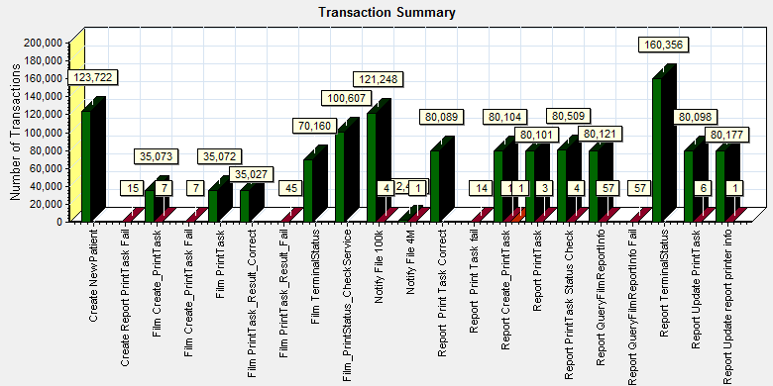

|  |  |  |
| --- | --- | --- |
| **Color** | **Scale** | **Measurement** |
|  | 1 | Pass |
|  | 1 | Fail |
|  | 1 | Stop |

E:\ECS\Reliability\Result\reliability_20170904\Report\dot_trans.gif

|  |
| --- |
| **Description:**Displays the number of transactions that passed, failed, stopped, or ended with errors. |
|  |

Figure 5.5.2.1 Transaction Summary

We can notice that there are some transactions failed during the testing work. We should find out the reason and fix it in the next version.

### Transaction response time result

We can get the transaction response time information from the figure as follow:

|  |
| --- |
|  |
| Average Transaction Response Time Graph |
| |  |  |  |  |  |  |  |  |  |  |  |  |  |  |  |  |  |  |  |  |  |  |  |  |  |  |  |  |  |  |  |  |  |  |  |  |  |  |  |  |  |  |  |  |  |  |  |  |  |  |  |  |  |  |  |  |  |  |  |  |  |  |  |  |  |  |  |  |  |  |  |  |  |  |  |  |  |  |  |  |  |  |  |  |  |  |  |  |  |  |  |  |  |  |  |  |  |  |  |  |  |  |  |  |  |  |  |  |  |  |  |  |  |  |  |  |  |  |  |  |  |  |  |  |  |  |  |  |  |  |  |  |  |  |  |  |  | | --- | --- | --- | --- | --- | --- | --- | --- | --- | --- | --- | --- | --- | --- | --- | --- | --- | --- | --- | --- | --- | --- | --- | --- | --- | --- | --- | --- | --- | --- | --- | --- | --- | --- | --- | --- | --- | --- | --- | --- | --- | --- | --- | --- | --- | --- | --- | --- | --- | --- | --- | --- | --- | --- | --- | --- | --- | --- | --- | --- | --- | --- | --- | --- | --- | --- | --- | --- | --- | --- | --- | --- | --- | --- | --- | --- | --- | --- | --- | --- | --- | --- | --- | --- | --- | --- | --- | --- | --- | --- | --- | --- | --- | --- | --- | --- | --- | --- | --- | --- | --- | --- | --- | --- | --- | --- | --- | --- | --- | --- | --- | --- | --- | --- | --- | --- | --- | --- | --- | --- | --- | --- | --- | --- | --- | --- | --- | --- | --- | --- | --- | --- | --- | --- | --- | --- | --- | | |  |  |  |  |  |  |  |  | | --- | --- | --- | --- | --- | --- | --- | --- | | **Color** | **Scale** | **Measurement** | **Graph's Minimum** | **Graph's Average** | **Graph's Maximum** | **Graph's Median** | **Graph's Std. Deviation** | |  | 1 | Create New Patient | 0.12 | 0.133 | 0.177 | 0.131 | 0.012 | |  | 1 | Film Create\_PrintTask | 0.798 | 0.85 | 0.978 | 0.839 | 0.038 | |  | 1 | Film PrintTask | 0.043 | 0.081 | 0.125 | 0.084 | 0.022 | |  | 1 | Film PrintTask\_Result\_Correct | 0 | 0 | 0 | 0 | 0 | |  | 1 | Film TerminalStatus | 0.027 | 0.043 | 0.067 | 0.044 | 0.011 | |  | 1 | Film\_PrintStatus\_CheckService | 0.026 | 0.044 | 0.079 | 0.042 | 0.014 | |  | 1 | Notify File 100k | 0.097 | 0.134 | 0.203 | 0.131 | 0.024 | |  | 1 | Notify File 4M | 0.164 | 0.239 | 0.498 | 0.227 | 0.062 | |  | 1 | Report Print Task Correct | 0 | 0 | 0 | 0 | 0 | |  | 1 | Report Create\_PrintTask | 0.798 | 0.842 | 0.903 | 0.843 | 0.027 | |  | 1 | Report PrintTask | 0.045 | 0.079 | 0.186 | 0.08 | 0.027 | |  | 1 | Report PrintTask Status Check | 0.028 | 0.044 | 0.079 | 0.043 | 0.013 | |  | 1 | Report QueryFilmReportInfo | 1.526 | 1.613 | 1.727 | 1.617 | 0.052 | |  | 1 | Report TerminalStatus | 0.025 | 0.041 | 0.058 | 0.041 | 0.01 | |  | 1 | Report Update PrintTask | 0.06 | 0.107 | 0.166 | 0.112 | 0.031 | |  | 1 | Report Update report printer info | 0.048 | 0.081 | 0.13 | 0.084 | 0.022 | | |  | |  | | E:\ECS\Reliability\Result\reliability_20170904\Report\dot_trans.gif | |  | | |  | | --- | | **Description:**Displays the average time taken to perform transactions during each second of the load test. This graph helps you determine whether the performance of the server is within acceptable minimum and maximum transaction performance time ranges defined for your system. | |  | | |
|  |
|  |
|  |
|  |
|  |
|  |

Figure 4.5.3.1 Transaction response time

This figure information shows all transactions` response time. The transaction times are all meets the requirements, we should focus on the transaction pass percentage.

## Bottleneck analysis

### Hardware usage analysis

During the testing work, we use the test tool to monitor the server hardware usage include the CPU, Memory, hard disk and etc.

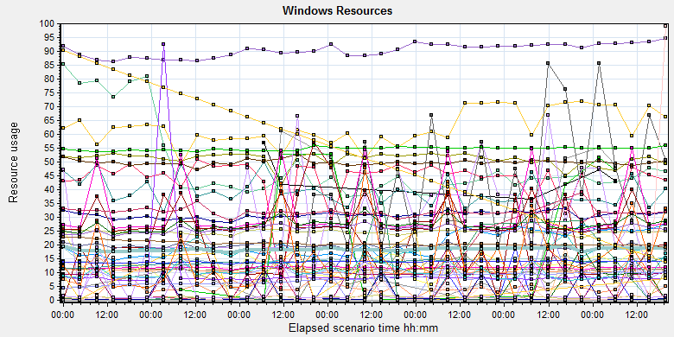

C:\Users\Administrator\AppData\Local\Temp\Report\dot_trans.gif

|  |  |  |  |  |  |  |
| --- | --- | --- | --- | --- | --- | --- |
| **Color** | **Scale** | **Measurement** | **Minimum** | **Average** | **Maximum** | **Std. Deviation** |
|  | 0.1 | % Disk Read Time (PhysicalDisk \_Total):10.184.129.208 | 0 | 35.517 | 420665.256 | 2686.532 |
|  | 0.01 | % Disk Time (PhysicalDisk \_Total):10.184.129.208 | 6.165 | 131.546 | 420665.256 | 2724.123 |
|  | 0.1 | % Disk Write Time (PhysicalDisk \_Total):10.184.129.208 | 0 | 96.028 | 16168.791 | 128.738 |
|  | 1 | % Idle Time (PhysicalDisk \_Total):10.184.129.208 | 0 | 62.477 | 95.713 | 19.54 |
|  | 1000 | % Interrupt Time (Processor \_Total):10.184.129.208 | 0 | 0.031 | 0.583 | 0.053 |
|  | 10 | % Privileged Time (Processor \_Total):10.184.129.208 | 0 | 1.454 | 11.269 | 1.062 |
|  | 10 | % Processor Time (Process AcquisitionServer):10.184.129.208 | 0 | 1.121 | 31.25 | 2.732 |
|  | 10000 | % Processor Time (Process auditServer):10.184.129.208 | 0 | 0 | 1.036 | 0.016 |
|  | 10 | % Processor Time (Process AutoDeliveryServer):10.184.129.208 | 0 | 2.466 | 74.093 | 5.933 |
|  | 1000 | % Processor Time (Process AutoForwardFilmService):10.184.129.208 | 0 | 0.012 | 9.326 | 0.081 |
|  | 100000 | % Processor Time (Process JP2MngSrv):10.184.129.208 | 0 | 0 | 0.521 | 0.004 |
|  | 10000 | % Processor Time (Process Kiosk.Alarm.KService):10.184.129.208 | 0 | 0.001 | 5.695 | 0.03 |
|  | 1000 | % Processor Time (Process LogServer):10.184.129.208 | 0 | 0.049 | 2.604 | 0.175 |
|  | 1 | % Processor Time (Process Ltthunkserver#1):10.184.129.208 | 0 | 39.665 | 108.29 | 26.872 |
|  | 1 | % Processor Time (Process Ltthunkserver#2):10.184.129.208 | 0 | 41.737 | 103.125 | 33.02 |
|  | 1 | % Processor Time (Process Ltthunkserver#3):10.184.129.208 | 0 | 38.757 | 100.521 | 30.736 |
|  | 1 | % Processor Time (Process Ltthunkserver#4):10.184.129.208 | 0 | 42.021 | 73.997 | 19.767 |
|  | 1 | % Processor Time (Process Ltthunkserver):10.184.129.208 | 0 | 50.923 | 110.937 | 27.008 |
|  | 1000 | % Processor Time (Process MessageQueue):10.184.129.208 | 0 | 0.039 | 4.663 | 0.157 |
|  | 100000 | % Processor Time (Process OamServer):10.184.129.208 | 0 | 0 | 0.521 | 0.003 |
|  | 1 | % Processor Time (Process OcrService):10.184.129.208 | 0 | 18.613 | 269.948 | 29.702 |
|  | 100000 | % Processor Time (Process PDCSenderServer):10.184.129.208 | 0 | 0 | 1.036 | 0.003 |
|  | 100 | % Processor Time (Process PrinterMonitor):10.184.129.208 | 0 | 0.202 | 37.824 | 0.476 |
|  | 100 | % Processor Time (Process PrintScheduler):10.184.129.208 | 0 | 0.499 | 8.29 | 0.859 |
|  | 10 | % Processor Time (Process PrintSCPServer):10.184.129.208 | 0 | 1.18 | 28.112 | 2.642 |
|  | 100000 | % Processor Time (Process PrintServer):10.184.129.208 | 0 | 0 | 0.532 | 0.012 |
|  | 100000 | % Processor Time (Process PSNotificationService):10.184.129.208 | 0 | 0 | 1.036 | 0.004 |
|  | 100000 | % Processor Time (Process RequestServer):10.184.129.208 | 0 | 0 | 0.521 | 0.003 |
|  | 100000 | % Processor Time (Process RuleServer):10.184.129.208 | 0 | 0 | 0.521 | 0.01 |
|  | 1 | % Processor Time (Process sqlservr):10.184.129.208 | 0.518 | 90.506 | 441.969 | 41.753 |
|  | 100000 | % Processor Time (Process sqlwriter):10.184.129.208 | 0 | 0 | 1.036 | 0.012 |
|  | 100000 | % Processor Time (Process SSCPServer):10.184.129.208 | 0 | 0 | 0.521 | 0.006 |
|  | 10000 | % Processor Time (Process TaskManager):10.184.129.208 | 0 | 0.001 | 1.042 | 0.019 |
|  | 1 | % Processor Time (Process w3wp#1):10.184.129.208 | 0 | 0.658 | 59329.938 | 132.324 |
|  | 10 | % Processor Time (Process w3wp#2):10.184.129.208 | 0 | 1.95 | 3518.654 | 8.12 |
|  | 100 | % Processor Time (Process w3wp#3):10.184.129.208 | 0 | 0.102 | 2831.863 | 6.407 |
|  | 1 | % Processor Time (Process w3wp#4):10.184.129.208 | 0 | 0.072 | 2809.844 | 10.44 |
|  | 1 | % Processor Time (Process w3wp#5):10.184.129.208 | 0 | 0.248 | 165.625 | 2.794 |
|  | 100 | % Processor Time (Process w3wp#6):10.184.129.208 | 0 | 0.094 | 205.7 | 2.985 |
|  | 1 | % Processor Time (Process w3wp):10.184.129.208 | 0 | 1.747 | 59238.846 | 279.06 |
|  | 1 | % Processor Time (Processor \_Total):10.184.129.208 | 0.259 | 18.416 | 93.847 | 9.456 |
|  | 0.001 | Available MBytes (Memory):10.184.129.208 | 18950 | 20595.596 | 26879 | 843.444 |
|  | 0.0001 | Avg. Disk Bytes/Transfer (PhysicalDisk \_Total):10.184.129.208 | 3840 | 112583.457 | 3347881.354 | 130006.702 |
|  | 1 | Avg. Disk Queue Length (PhysicalDisk \_Total):10.184.129.208 | 0.061 | 1.315 | 4206.653 | 27.248 |
|  | 10 | Avg. Disk Read Queue Length (PhysicalDisk \_Total):10.184.129.208 | 0 | 0.355 | 4206.653 | 26.872 |
|  | 10 | Avg. Disk Write Queue Length (PhysicalDisk \_Total):10.184.129.208 | 0 | 0.96 | 161.688 | 1.287 |
|  | 0.001 | Bytes Total/sec (Server):10.184.129.208 | 41262.597 | 54839.942 | 72665.477 | 1168.854 |
|  | 1E-07 | Cache Bytes (Memory):10.184.129.208 | 30294016 | 77480101.072 | 119779328 | 18178802.733 |
|  | 1E-09 | Committed Bytes (Memory):10.184.129.208 | 6289543168 | 13701609518.274 | 15868743680 | 932443344.191 |
|  | 0.001 | Context Switches/sec (System):10.184.129.208 | 1861.054 | 13903.056 | 122996.688 | 8243.919 |
|  | 10 | Current Disk Queue Length (PhysicalDisk \_Total):10.184.129.208 | 0 | 1.061 | 246 | 3.536 |
|  | 1E-05 | Disk Bytes/sec (PhysicalDisk \_Total):10.184.129.208 | 24488.302 | 3194954.848 | 289124962.093 | 4490378.195 |
|  | 1E-05 | Disk Read Bytes/sec (PhysicalDisk \_Total):10.184.129.208 | 0 | 357918.797 | 56314598.843 | 1833232.012 |
|  | 10 | Disk Reads/sec (PhysicalDisk \_Total):10.184.129.208 | 0 | 1.598 | 1409.925 | 13.316 |
|  | 1 | Disk Transfers/sec (PhysicalDisk \_Total):10.184.129.208 | 1.994 | 27.335 | 1458.04 | 19.715 |
|  | 1E-05 | Disk Write Bytes/sec (PhysicalDisk \_Total):10.184.129.208 | 0 | 2837036.051 | 289124962.093 | 3287007.591 |
|  | 1 | Disk Writes/sec (PhysicalDisk \_Total):10.184.129.208 | 0 | 25.737 | 382.713 | 13.731 |
|  | 0.01 | File Data Operations/sec (System):10.184.129.208 | 208.518 | 3186.21 | 37742.778 | 3047.817 |
|  | 0.0001 | Free Megabytes (LogicalDisk \_Total):10.184.129.208 | 126753 | 516809.108 | 913839 | 226064.657 |
|  | 1E-07 | System Cache Resident Bytes (Memory):10.184.129.208 | 30294016 | 77480149.435 | 119779328 | 18178841.085 |

E:\ECS\Reliability\Result\reliability_20170904\Report\dot_trans.gif

|  |
| --- |
| **Description:**Displays a summary of the System Resources usage for each Windows based host. |
|  |

C:\Users\Administrator\Desktop\Relalibility\reliability_20170802\Report\dot_trans.gif

Follow this information we can get that:

The CPU usage do not exist bottleneck, the process time is about 18% (*% Processor Time (Processor \_Total)*). CPU resources do not have stress.

The memory available value is 18.9G and the system use 8 G. The memory do not has bottleneck under current testing stress.

The disk read and writes stress is also small; do not find the disk bottleneck.

### SQL Server resource usage analysis

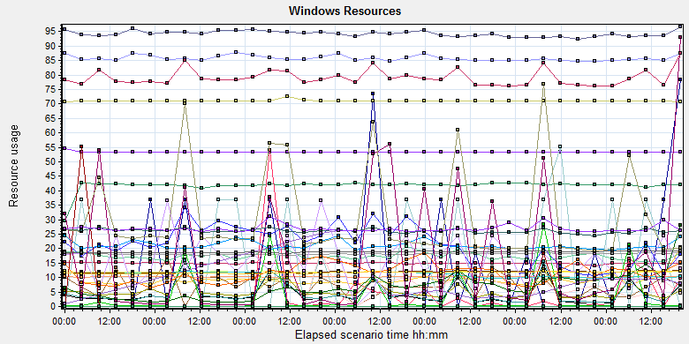

|  |  |  |  |  |  |  |  |  |  |  |  |  |  |  |  |  |  |  |  |  |  |  |  |  |  |  |  |  |  |  |  |  |  |  |  |  |  |  |  |  |  |  |  |  |  |  |  |  |  |  |  |  |  |  |  |  |  |  |  |  |  |  |  |  |  |  |  |  |  |  |  |  |  |  |  |  |  |  |  |  |  |  |  |  |  |  |  |  |  |  |  |  |  |  |  |  |  |  |  |  |  |  |  |  |  |  |  |  |  |  |  |  |  |  |  |  |  |  |  |  |  |  |  |  |  |  |  |  |  |  |  |  |  |  |  |  |  |  |  |  |  |  |  |  |  |  |  |  |  |  |  |  |  |  |  |  |  |  |  |  |  |  |  |  |  |  |  |  |  |  |  |  |  |  |  |  |  |  |  |  |  |  |  |  |  |  |  |  |  |  |  |  |  |  |  |  |  |  |  |  |  |  |  |  |  |  |  |  |  |  |  |  |  |  |  |  |  |  |  |  |  |  |  |  |  |  |  |  |  |  |  |  |  |  |  |  |  |  |  |  |  |  |  |  |  |  |  |  |  |  |  |  |  |  |  |  |  |  |  |  |  |  |  |  |  |  |  |  |  |  |  |  |  |  |  |  |  |  |  |  |  |  |  |  |  |  |
| --- | --- | --- | --- | --- | --- | --- | --- | --- | --- | --- | --- | --- | --- | --- | --- | --- | --- | --- | --- | --- | --- | --- | --- | --- | --- | --- | --- | --- | --- | --- | --- | --- | --- | --- | --- | --- | --- | --- | --- | --- | --- | --- | --- | --- | --- | --- | --- | --- | --- | --- | --- | --- | --- | --- | --- | --- | --- | --- | --- | --- | --- | --- | --- | --- | --- | --- | --- | --- | --- | --- | --- | --- | --- | --- | --- | --- | --- | --- | --- | --- | --- | --- | --- | --- | --- | --- | --- | --- | --- | --- | --- | --- | --- | --- | --- | --- | --- | --- | --- | --- | --- | --- | --- | --- | --- | --- | --- | --- | --- | --- | --- | --- | --- | --- | --- | --- | --- | --- | --- | --- | --- | --- | --- | --- | --- | --- | --- | --- | --- | --- | --- | --- | --- | --- | --- | --- | --- | --- | --- | --- | --- | --- | --- | --- | --- | --- | --- | --- | --- | --- | --- | --- | --- | --- | --- | --- | --- | --- | --- | --- | --- | --- | --- | --- | --- | --- | --- | --- | --- | --- | --- | --- | --- | --- | --- | --- | --- | --- | --- | --- | --- | --- | --- | --- | --- | --- | --- | --- | --- | --- | --- | --- | --- | --- | --- | --- | --- | --- | --- | --- | --- | --- | --- | --- | --- | --- | --- | --- | --- | --- | --- | --- | --- | --- | --- | --- | --- | --- | --- | --- | --- | --- | --- | --- | --- | --- | --- | --- | --- | --- | --- | --- | --- | --- | --- | --- | --- | --- | --- | --- | --- | --- | --- | --- | --- | --- | --- | --- | --- | --- | --- | --- | --- | --- | --- | --- | --- | --- | --- | --- | --- | --- | --- | --- | --- | --- | --- | --- | --- | --- | --- | --- | --- | --- | --- | --- | --- | --- | --- | --- | --- | --- | --- | --- | --- | --- |
| |  |  |  |  |  |  |  |  |  |  |  |  |  |  |  |  |  |  |  |  |  |  |  |  |  |  |  |  |  |  |  |  |  |  |  |  |  |  |  |  |  |  |  |  |  |  |  |  |  |  |  |  |  |  |  |  |  |  |  |  |  |  |  |  |  |  |  |  |  |  |  |  |  |  |  |  |  |  |  |  |  |  |  |  |  |  |  |  |  |  |  |  |  |  |  |  |  |  |  |  |  |  |  |  |  |  |  |  |  |  |  |  |  |  |  |  |  |  |  |  |  |  |  |  |  |  |  |  |  |  |  |  |  |  |  |  |  |  |  |  |  |  |  |  |  |  |  |  |  |  |  |  |  |  |  |  |  |  |  |  |  |  |  |  |  |  |  |  |  |  |  |  |  |  |  |  |  |  |  |  |  |  |  |  |  |  |  |  |  |  |  |  |  |  |  |  |  |  |  |  |  |  |  |  |  |  |  |  |  |  |  |  |  |  |  |  |  |  |  |  |  |  |  |  |  |  |  |  |  |  |  |  |  |  |  |  |  |  |  |  |  |  |  |  |  |  |  |  |  |  |  |  |  |  |  |  |  |  |  |  |  |  |  |  |  |  |  |  |  |  |  |  |  |  |  |  |  |  |  |  |  | | --- | --- | --- | --- | --- | --- | --- | --- | --- | --- | --- | --- | --- | --- | --- | --- | --- | --- | --- | --- | --- | --- | --- | --- | --- | --- | --- | --- | --- | --- | --- | --- | --- | --- | --- | --- | --- | --- | --- | --- | --- | --- | --- | --- | --- | --- | --- | --- | --- | --- | --- | --- | --- | --- | --- | --- | --- | --- | --- | --- | --- | --- | --- | --- | --- | --- | --- | --- | --- | --- | --- | --- | --- | --- | --- | --- | --- | --- | --- | --- | --- | --- | --- | --- | --- | --- | --- | --- | --- | --- | --- | --- | --- | --- | --- | --- | --- | --- | --- | --- | --- | --- | --- | --- | --- | --- | --- | --- | --- | --- | --- | --- | --- | --- | --- | --- | --- | --- | --- | --- | --- | --- | --- | --- | --- | --- | --- | --- | --- | --- | --- | --- | --- | --- | --- | --- | --- | --- | --- | --- | --- | --- | --- | --- | --- | --- | --- | --- | --- | --- | --- | --- | --- | --- | --- | --- | --- | --- | --- | --- | --- | --- | --- | --- | --- | --- | --- | --- | --- | --- | --- | --- | --- | --- | --- | --- | --- | --- | --- | --- | --- | --- | --- | --- | --- | --- | --- | --- | --- | --- | --- | --- | --- | --- | --- | --- | --- | --- | --- | --- | --- | --- | --- | --- | --- | --- | --- | --- | --- | --- | --- | --- | --- | --- | --- | --- | --- | --- | --- | --- | --- | --- | --- | --- | --- | --- | --- | --- | --- | --- | --- | --- | --- | --- | --- | --- | --- | --- | --- | --- | --- | --- | --- | --- | --- | --- | --- | --- | --- | --- | --- | --- | --- | --- | --- | --- | --- | --- | --- | --- | --- | --- | --- | --- | --- | --- | --- | --- | --- | --- | --- | --- | --- | --- | --- | --- | --- | --- | --- | --- | --- | | |  |  |  |  |  |  |  | | --- | --- | --- | --- | --- | --- | --- | | **Color** | **Scale** | **Measurement** | **Minimum** | **Average** | **Maximum** | **Std. Deviation** | |  | 1 | Cache Hit Ratio (MSSQL$GCPACSWS|Catalog Metadata WGGC):10.184.129.208 | 53.101 | 53.434 | 86.681 | 0.547 | |  | 0.0001 | Cursor memory usage (MSSQL$GCPACSWS|Cursor Manager by Type \_Total):10.184.129.208 | 3224 | 417921.733 | 433616 | 31328.554 | |  | 10 | Cursor Requests/sec (MSSQL$GCPACSWS|Cursor Manager by Type \_Total):10.184.129.208 | 0 | 1.493 | 19.261 | 1.744 | |  | 100 | Distributed Query (MSSQL$GCPACSWS|Exec Statistics Average execution time (ms)):10.184.129.208 | 0 | 0.092 | 308 | 1.139 | |  | 100000 | Distributed Query (MSSQL$GCPACSWS|Exec Statistics Cumulative execution time (ms) per second):10.184.129.208 | 0 | 0 | 2 | 0.012 | |  | 100000 | Distributed Query (MSSQL$GCPACSWS|Exec Statistics Execs in progress):10.184.129.208 | 0 | 0 | 1 | 0.011 | |  | 1E-15 | Distributed Query (MSSQL$GCPACSWS|Exec Statistics Execs started per second):10.184.129.208 | 0 | 7.15619501225664E+15 | 1.84467440737096E+19 | 3.6325925563652E+17 | |  | 1 | Errors/sec (MSSQL$GCPACSWS|SQL Errors \_Total):10.184.129.208 | 0 | 10.253 | 30.892 | 2.769 | |  | 10 | Errors/sec (MSSQL$GCPACSWS|SQL Errors User Errors):10.184.129.208 | 0 | 7.109 | 15.611 | 1.995 | |  | 100 | Extended Procedures (MSSQL$GCPACSWS|Exec Statistics Average execution time (ms)):10.184.129.208 | 0 | 0.038 | 113 | 1.751 | |  | 1 | Full Scans/sec (MSSQL$GCPACSWS|Access Methods):10.184.129.208 | 3.321 | 85.819 | 2843.844 | 78.418 | |  | 0.001 | Index Searches/sec (MSSQL$GCPACSWS|Access Methods):10.184.129.208 | 214.917 | 12005.964 | 97417.113 | 11190.602 | |  | 1000 | Latch waits/sec (MSOLAP$GCPACSWS|Locks):10.184.129.208 | 0 | 0.017 | 0.997 | 0.076 | |  | 1000 | Lazy writes/sec (MSSQL$GCPACSWS|Buffer Manager):10.184.129.208 | 0 | 0.003 | 54.154 | 0.257 | |  | 0.0001 | Lock Requests/sec (MSSQL$GCPACSWS|Locks \_Total):10.184.129.208 | 653.524 | 181606.373 | 631871.863 | 49077.849 | |  | 1 | Lock Timeouts/sec (MSSQL$GCPACSWS|Locks \_Total):10.184.129.208 | 0 | 3.499 | 26833.464 | 215.908 | |  | 0.1 | Lock Wait Time (ms) (MSSQL$GCPACSWS|Locks \_Total):10.184.129.208 | 0 | 43.523 | 470345.842 | 1901.346 | |  | 0.1 | Lock waits (MSSQL$GCPACSWS|Wait Statistics Average wait time (ms)):10.184.129.208 | 0 | 52.265 | 83934 | 749.294 | |  | 100 | Lock waits (MSSQL$GCPACSWS|Wait Statistics Waits in progress):10.184.129.208 | 0 | 0.045 | 37 | 0.633 | |  | 100 | Lock Waits/sec (MSSQL$GCPACSWS|Locks \_Total):10.184.129.208 | 0 | 0.21 | 20.26 | 0.387 | |  | 1 | Log write waits (MSSQL$GCPACSWS|Wait Statistics Average wait time (ms)):10.184.129.208 | 0 | 11.081 | 45 | 1.558 | |  | 0.1 | Logical Connections (MSSQL$GCPACSWS|General Statistics):10.184.129.208 | 89 | 118.825 | 184 | 6.717 | |  | 100 | Logins/sec (MSSQL$GCPACSWS|General Statistics):10.184.129.208 | 0 | 0.212 | 9.633 | 0.286 | |  | 100 | Logouts/sec (MSSQL$GCPACSWS|General Statistics):10.184.129.208 | 0 | 0.212 | 12.621 | 0.303 | |  | 1 | Lookups/sec (MSOLAP$GCPACSWS|Cache):10.184.129.208 | 0 | 0 | 0 | 0 | |  | 100000 | Number of Deadlocks/sec (MSSQL$GCPACSWS|Locks \_Total):10.184.129.208 | 0 | 0 | 0.332 | 0.007 | |  | 100 | OLEDB calls (MSSQL$GCPACSWS|Exec Statistics Average execution time (ms)):10.184.129.208 | 0 | 0.116 | 78 | 0.748 | |  | 1 | Page IO latch waits (MSSQL$GCPACSWS|Wait Statistics Average wait time (ms)):10.184.129.208 | 0 | 6.854 | 11163 | 57.352 | |  | 100000 | Page latch waits (MSSQL$GCPACSWS|Wait Statistics Waits in progress):10.184.129.208 | 0 | 0 | 1 | 0.004 | |  | 0.0001 | Page life expectancy (MSSQL$GCPACSWS|Buffer Manager):10.184.129.208 | 200 | 103798.646 | 261546 | 75035.383 | |  | 0.0001 | Page lookups/sec (MSSQL$GCPACSWS|Buffer Manager):10.184.129.208 | 1360.377 | 188780.379 | 571455.903 | 56763.781 | |  | 10 | Page reads/sec (MSSQL$GCPACSWS|Buffer Manager):10.184.129.208 | 0 | 1.72 | 7067.629 | 61.819 | |  | 10 | Page writes/sec (MSSQL$GCPACSWS|Buffer Manager):10.184.129.208 | 0 | 3.067 | 2901.905 | 26.628 | |  | 10 | Safe Auto-Params/sec (MSSQL$GCPACSWS|SQL Statistics):10.184.129.208 | 0 | 2.613 | 35.869 | 2.506 | |  | 1 | SQL Compilations/sec (MSSQL$GCPACSWS|SQL Statistics):10.184.129.208 | 13.613 | 94.298 | 186.658 | 9.705 | |  | 100 | SQL Re-Compilations/sec (MSSQL$GCPACSWS|SQL Statistics):10.184.129.208 | 0 | 0.269 | 9.631 | 0.311 | |  | 1 | Total deadlocks detected (MSOLAP$GCPACSWS|Locks):10.184.129.208 | 0 | 0 | 0 | 0 | |  | 10 | Transactions (MSSQL$GCPACSWS|Transactions):10.184.129.208 | 6 | 7.903 | 177 | 3.596 | |  | 0.1 | User Connections (MSSQL$GCPACSWS|General Statistics):10.184.129.208 | 89 | 117.524 | 183 | 6.551 | | |  | |  | | E:\ECS\Reliability\Result\reliability_20170904\Report\dot_trans.gif |   E:\ECS\Reliability\Result\reliability_20170904\Report\dot_trans.gif   |  | | --- | | **Description:**Displays a summary of the System Resources usage for each Windows based host. | |  |   C:\Users\Administrator\Desktop\Relalibility\reliability_20170802\Report\dot_trans.gif |

Figure .6.2.1 Database result

Follow the SQL server monitor resource, we can find the Database has some issues that make the system reliability not well:

There are cursors operations exist in the database:

|  |  |  |  |  |  |  |
| --- | --- | --- | --- | --- | --- | --- |
|  | 0.0001 | Cursor memory usage (MSSQL$GCPACSWS|Cursor Manager by Type \_Total):10.184.129.208 | 3224 | 417921.733 | 433616 | 31328.554 |
|  | 10 | Cursor Requests/sec (MSSQL$GCPACSWS|Cursor Manager by Type \_Total):10.184.129.208 | 0 | 1.493 | 19.261 | 1.744 |

Database does the cursor operations every 1.4/ seconds. SQL server suggests users to do the operation base on column data. Please indentify the SQL statement and do some enhance works.

There are some error happens during the testing work:

|  |  |  |  |  |  |  |
| --- | --- | --- | --- | --- | --- | --- |
|  | 1 | Errors/sec (MSSQL$GCPACSWS|SQL Errors \_Total):10.184.129.208 | 0 | 10.253 | 30.892 | 2.769 |
|  | 10 | Errors/sec (MSSQL$GCPACSWS|SQL Errors User Errors):10.184.129.208 | 0 | 7.109 | 15.611 | 1.995 |

Database has 10.25 errors every second and 7.1/ records are user errors. It maybe cause by the dead lock or other issues.

There are too many full scans operations exist in the database:

|  |  |  |  |  |  |  |
| --- | --- | --- | --- | --- | --- | --- |
|  | 1 | Full Scans/sec (MSSQL$GCPACSWS|Access Methods):10.184.129.208 | 3.321 | 85.819 | 2843.844 | 78.418 |

Database has full scans issues and average value is 86/sec. This issue will affect the SQL statement executes slowly because it does not use the index. Some operations will cause the full scans such as select count (\*), use <> and! =, use like fuzzy query and query from view etc. Please enhance the SQL statement performance ASAP.

There are some locks issues exist in the database:

|  |  |  |  |  |  |  |
| --- | --- | --- | --- | --- | --- | --- |
|  |  |  |  |  |  |  |
|  | 0.1 | Lock Wait Time (ms) (MSSQL$GCPACSWS|Locks \_Total):10.184.129.208 | 0 | 43.523 | 470345.842 | 1901.346 |
|  | 0.1 | Lock waits (MSSQL$GCPACSWS|Wait Statistics Average wait time (ms)):10.184.129.208 | 0 | 52.265 | 83934 | 749.294 |
|  | 100 | Lock waits (MSSQL$GCPACSWS|Wait Statistics Waits in progress):10.184.129.208 | 0 | 0.045 | 37 | 0.633 |
|  | 100 | Lock Waits/sec (MSSQL$GCPACSWS|Locks \_Total):10.184.129.208 | 0 | 0.21 | 20.26 | 0.387 |
|  | 100000 | Number of Deadlocks/sec (MSSQL$GCPACSWS|Locks \_Total):10.184.129.208 | 0 | 0 | 0.332 | 0.007 |
|  | 1 | Lock Timeouts/sec (MSSQL$GCPACSWS|Locks \_Total):10.184.129.208 | 0 | 3.499 | 26833.464 | 215.908 |

We can see that the average lock waits time is 0.043 seconds and timeouts average value is 3.5/seconds. There are 0.21 locks and no deadlocks every second. The database design is better than B09, the deadlocks issues are fixed by the team.

There are about 118 database connections in the database, but login and logout frequency is 0.212/sec. The connection numbers are OK for database.

|  |  |  |  |  |  |  |
| --- | --- | --- | --- | --- | --- | --- |
|  | 0.1 | Logical Connections (MSSQL$GCPACSWS|General Statistics):10.184.129.208 | 89 | 118.825 | 184 | 6.717 |
|  | 100 | Logins/sec (MSSQL$GCPACSWS|General Statistics):10.184.129.208 | 0 | 0.212 | 9.633 | 0.286 |
|  | 100 | Logouts/sec (MSSQL$GCPACSWS|General Statistics):10.184.129.208 | 0 | 0.212 | 12.621 | 0.303 |

## Test Error

There are some errors exist in the testing work and logged as follow:

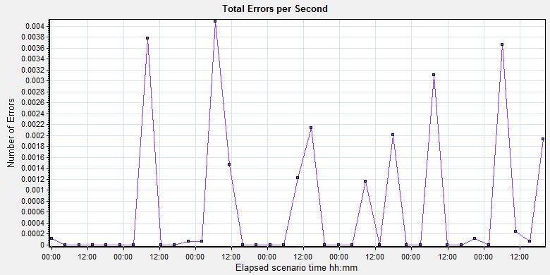

|  |  |  |  |  |  |  |  |
| --- | --- | --- | --- | --- | --- | --- | --- |
| Color | Scale | Measurement | Graph Minimum | Average | Graph Maximum | Graph Median | Graph Std. Deviation |
|  | 1 | All | 0 | 0.001 | 0.004 | 0 | 0.001 |

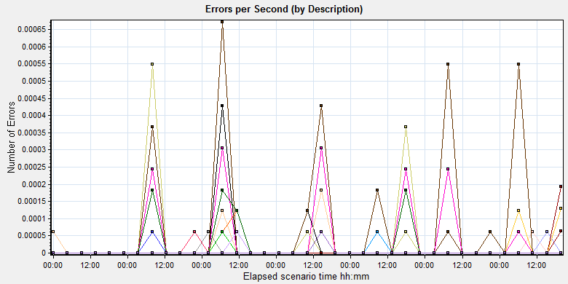

E:\ECS\Reliability\Result\reliability_20170904\Report\dot_trans.gif

|  |
| --- |
|  |
|  |

|  |  |  |
| --- | --- | --- |
| No | description | Counts |
| 1 | Monitor name :MS IIS. Cannot access data for measurement .NET CLR Exceptions|# of Exceps Thrown / sec|\_Global\_ on machine 10.184.129.208.  Details: A counter with a negative value was detected. | 18021 |
| 2 | Action.c(266): Continuing after Error -27492: "HttpSendRequest" failed, Windows error code=12002 and retry limit (0) exceeded for URL="http://10.184.129.208/EHDPS/printtask/create?tid=Terminal\*\*" | 80 |
| 3 | Action.c(114): Continuing after Error -26377: No match found for the requested parameter "TaskID". Check whether the requested boundaries exist in the response data. Also, if the data you want to save exceeds 10240 bytes, use web\_set\_max\_html\_param\_len to increase the parameter size | 119 |
| 4 | Action.c(266): Continuing after Error -26374: The above "not found" error(s) may be explained by header and body byte counts being 0 and 0, respectively. | 70 |
| 5 | Action.c(134): Error: Try to get the Print task ID failed:Status: A201708\*\*\*\*\*\* : K2\_1\*\*\*  Action.c(410): Error: The report task print failed! taskID: 42\*\*\*\* From Terminal: Terminal\*\*\* | 143 |

Error analyzes:

1. These errors caused by the test tool, some monitor counter cannot find in the server. It is not error for our testing works.
2. This error happened when user wants to create print task by using EHDPS services.
3. These errors happened when user want to get the taskID, reportID or reportPath. Service will use it print films or reports. The errors are caused by the web service, it do not return the information.
4. These errors happened when related services are stop services. Some services are stop, then the script cannot execute successfully.
5. These errors show that the films or reports are print failed. It caused by the task management applications and the root reason maybe is database lock the tables or services stop response.

We analysis the errors find that it happens periodically. The root reason is the LRU application will lock the tables. The applications will crash because the SQL statement timeout. We find some errors as follow:

2017-08-31 00:10:35,369 FATAL - module:SQLServerDAL\_SqlHelper , message:----------Exception----------

Timeout 时间已到。在操作完成之前超时时间已过或服务器未响应。

在 System.Data.SqlClient.SqlInternalConnection.OnError(SqlException exception, Boolean breakConnection, Action`1 wrapCloseInAction)

在 System.Data.SqlClient.TdsParser.ThrowExceptionAndWarning(TdsParserStateObject stateObj, Boolean callerHasConnectionLock, Boolean asyncClose)

在 System.Data.SqlClient.TdsParserStateObject.ReadSniError(TdsParserStateObject stateObj, UInt32 error)

在 System.Data.SqlClient.TdsParserStateObject.ReadSniSyncOverAsync()

在 System.Data.SqlClient.TdsParserStateObject.TryReadNetworkPacket()

在 System.Data.SqlClient.TdsParserStateObject.TryPrepareBuffer()

在 System.Data.SqlClient.TdsParserStateObject.TryReadByte(Byte& value)

在 System.Data.SqlClient.TdsParser.TryRun(RunBehavior runBehavior, SqlCommand cmdHandler, SqlDataReader dataStream, BulkCopySimpleResultSet bulkCopyHandler, TdsParserStateObject stateObj, Boolean& dataReady)

在 System.Data.SqlClient.SqlCommand.FinishExecuteReader(SqlDataReader ds, RunBehavior runBehavior, String resetOptionsString)

在 System.Data.SqlClient.SqlCommand.RunExecuteReaderTds(CommandBehavior cmdBehavior, RunBehavior runBehavior, Boolean returnStream, Boolean async, Int32 timeout, Task& task, Boolean asyncWrite, SqlDataReader ds)

在 System.Data.SqlClient.SqlCommand.RunExecuteReader(CommandBehavior cmdBehavior, RunBehavior runBehavior, Boolean returnStream, String method, TaskCompletionSource`1 completion, Int32 timeout, Task& task, Boolean asyncWrite)

在 System.Data.SqlClient.SqlCommand.InternalExecuteNonQuery(TaskCompletionSource`1 completion, String methodName, Boolean sendToPipe, Int32 timeout, Boolean asyncWrite)

在 System.Data.SqlClient.SqlCommand.ExecuteNonQuery()

在 LRULogic.Domain.Util.SqlHelper.ExecuteNonQuery(String strSql, SqlParameter[] ParaList, GXDatabase db, CommandType commandType) 位置 e:\work\Puma\Kiosk\PS\Server\LRUService\LRULogic\Domain\Util\SqlHelper.cs:行号 222 at:LRULogic.Domain.Worker.DbJob.ExeStoreProc-Line:71, user:SqlHelper

2017-08-31 00:10:35,369 FATAL - module:SQLServerDAL\_SqlHelper , message:WGGC.dbo.AFP\_SP\_ExpiredFilmLRU at:LRULogic.Domain.Worker.DbJob.ExeStoreProc-Line:71, user:SqlHelper

2017-08-31 00:10:35,369 ERROR - ----------Exception----------

Timeout 时间已到。在操作完成之前超时时间已过或服务器未响应。

在 System.Data.SqlClient.SqlInternalConnection.OnError(SqlException exception, Boolean breakConnection, Action`1 wrapCloseInAction)

在 System.Data.SqlClient.TdsParser.ThrowExceptionAndWarning(TdsParserStateObject stateObj, Boolean callerHasConnectionLock, Boolean asyncClose)

在 System.Data.SqlClient.TdsParserStateObject.ReadSniError(TdsParserStateObject stateObj, UInt32 error)

在 System.Data.SqlClient.TdsParserStateObject.ReadSniSyncOverAsync()

在 System.Data.SqlClient.TdsParserStateObject.TryReadNetworkPacket()

在 System.Data.SqlClient.TdsParserStateObject.TryPrepareBuffer()

在 System.Data.SqlClient.TdsParserStateObject.TryReadByte(Byte& value)

在 System.Data.SqlClient.TdsParser.TryRun(RunBehavior runBehavior, SqlCommand cmdHandler, SqlDataReader dataStream, BulkCopySimpleResultSet bulkCopyHandler, TdsParserStateObject stateObj, Boolean& dataReady)

在 System.Data.SqlClient.SqlCommand.FinishExecuteReader(SqlDataReader ds, RunBehavior runBehavior, String resetOptionsString)

在 System.Data.SqlClient.SqlCommand.RunExecuteReaderTds(CommandBehavior cmdBehavior, RunBehavior runBehavior, Boolean returnStream, Boolean async, Int32 timeout, Task& task, Boolean asyncWrite, SqlDataReader ds)

在 System.Data.SqlClient.SqlCommand.RunExecuteReader(CommandBehavior cmdBehavior, RunBehavior runBehavior, Boolean returnStream, String method, TaskCompletionSource`1 completion, Int32 timeout, Task& task, Boolean asyncWrite)

在 System.Data.SqlClient.SqlCommand.InternalExecuteNonQuery(TaskCompletionSource`1 completion, String methodName, Boolean sendToPipe, Int32 timeout, Boolean asyncWrite)

在 System.Data.SqlClient.SqlCommand.ExecuteNonQuery()

在 LRULogic.Domain.Util.SqlHelper.ExecuteNonQuery(String strSql, SqlParameter[] ParaList, GXDatabase db, CommandType commandType) 位置 e:\work\Puma\Kiosk\PS\Server\LRUService\LRULogic\Domain\Util\SqlHelper.cs:行号 233

在 LRULogic.Domain.Worker.DbJob.ExeStoreProc(StoreProc sp) 位置 e:\work\Puma\Kiosk\PS\Server\LRUService\LRULogic\Domain\Worker\DbJob.cs:行号 71

在 LRULogic.Domain.Worker.DbJob.Execute() 位置 e:\work\Puma\Kiosk\PS\Server\LRUService\LRULogic\Domain\Worker\DbJob.cs:行号 29 at:JobScheduler.Impl.SchedulerBase.executeJobs-Line:31

2017-08-31 00:10:35,369 INFO - Job.Name=Delete Expired Film stopped.

More log information you can view the content in these files:



Develop team need to enhance the performance of LRU function. QA team has submitted the defect to help team to monitor the issues.

## Test Conclusion

We execute the whole testing works for 7 days, 8 minutes and 26 seconds..

During the testing work, we archived large data in system:

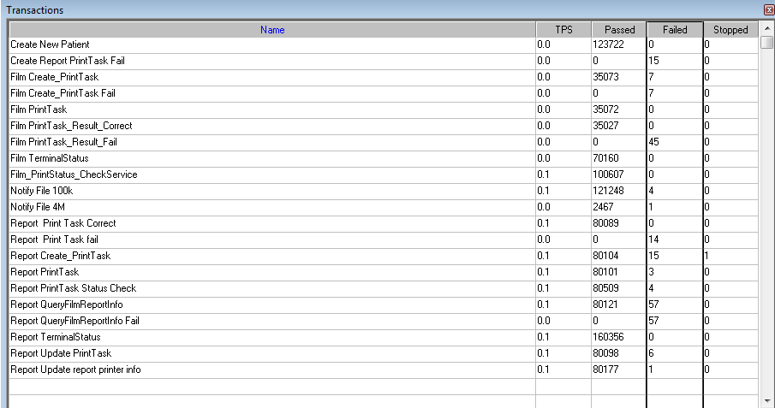

|  |  |  |  |  |
| --- | --- | --- | --- | --- |
| **Transaction** | **All** | **Pass** | **Failed** | **Percentage** |
| Report archived | 123720 | 123715 | 5 | 99.996% |
| Film Print | 35072 | 35027 | 45 | 99.87% |
| Report Print | 80103 | 80089 | 14 | 99.982% |
| Report print from real terminal: | 5063 | 5035 | 28 | 99.447% |

We find that all tested transactions correct execute percent have meet the requirements (>=99%). But the LRU timeout issues will make down the reliability of system. We should fix them as soon as possible.

After team update the application and integration service. The performance and reliability has enhanced.

After 3 phase testing works, the reliability of PUMA has enhanced and meets the requirements. Thanks for all members of Team.

Describe the overall verification and validation testing objectives.

Please make appropriate modifications to the sample text so it accurately reflects this project.

**<End of Document>**